**Project Report**

**On**

**LINEAR PROGRAMMING IN CONSTRUCTION AND MANUFACTURING**

*submitted towards the partial fulfillment of*

*the requirement for the award of the degree of*

**Bachelor of Technology**

In

**Electrical Engineering**

Submitted by

**Ritul**

**2K20/EE/221**

Under the Supervision

Of

**Dr. Radheshyam Saha**

Delhi Technological University

Bawana Road. Delhi -110042

DELHI TECHNOLOGICAL UNIVERSITY

(FORMERLY Delhi College of Engineering) Bawana Road, Delhi-110042

## CANDIDATE’S DECLARATION

I, **Ritul (2K20/EE/221)** student of B. Tech. hereby declare that the project titled ‘**Linear Programming in Construction** **and Manufacturing’** which is submitted by us to the Department of Electrical Engineering, Delhi Technological University, Delhi in partial fulfilment of the requirement for the award of the degree of Bachelor of Technology, is original and not copied from any source without proper citation. This work has not previously formed the basis for the award of any Degree, Diploma Associateship, Fellowship or other similar title or recognition.

**Ritul**

**2K20/EE/221**

DELHI TECHNOLOGICAL UNIVERSITY

(FORMERLY Delhi College of Engineering) Bawana Road, Delhi-110042

## CERTIFICATE

I hereby certify that the project titled ‘**Linear Programming in Construction** **and Manufacturing’** which is submitted by, **Ritul (2K20/EE/221)** of Delhi Technological University, Delhi in complete fulfilment of the requirement for the award of the degree of the Bachelor of Technology, is a record of the project work carried out by the students under my supervision. To the best of my knowledge this work has not been submitted in part or full for any Degree or Diploma to this University or elsewhere.

Place: Delhi **Dr.Radheshyam Saha**

**SUPERVISOR**

DELHI TECHNOLOGICAL UNIVERSITY

(FORMERLY Delhi College of Engineering) Bawana Road, Delhi-110042

## ACKNOWLEDGEMENT

In performing our major project, we had to take the help and guideline of some respected persons, who deserve our greatest gratitude. The completion of this assignment gives us much pleasure. I would like to show our gratitude to **Dr. Radheshyam Saha**, mentors for our project. Giving us a good guideline for the report throughout numerous consultations. I would also like to extend our deepest gratitude to all those who have directly and indirectly guided us in writing this assignment.

Many people our classmates and team members itself, have made valuable comment suggestions on this proposal which gave us an inspiration to improve our assignment. We thank all the people for their help directly and indirectly to complete our assignment.

In addition, we would like to thank Department of Electrical Engineering, Delhi Technological University for giving us the opportunity to work on this topic.

**ABSTRACT**

In the era of globalization, integrated planning for production, workforce and capacity are the key factors for attaining success in any industry. Linear programming is the branch of applied mathematics that deals in particular class of business-related problems for optimization. It contains a linear objective function which is to be optimized (maximize or minimize) subject to a certain number of constraints. The constraints are also linear inequalities or linear equation in the variables used in objective function. An application of linear programming technique in business is to maximize the total profit, to minimize the total cost, to arrange the best times to start and finish project etc. It is a mathematical technique for finding the best optimal solution for a company.

We also going to solve these problems in Construction and Manufacturing by using Linear Programming:

* Optimizing use of resources.
* Determining most economic product mix.
* Transportation and routing problems.
* Personnel assignment.
* Determining Optimum size of bid.
* Location of new production plants, offices and warehouses.



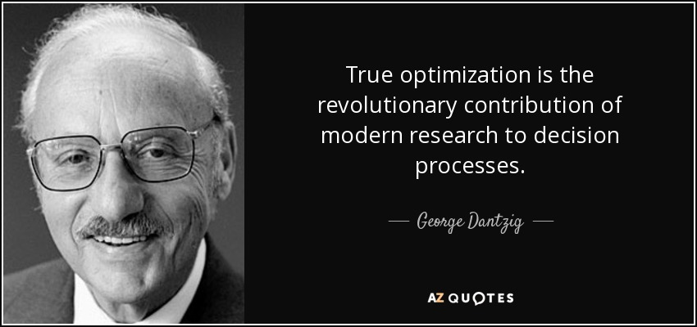***LINEAR PROGRAMMING IN CONSTRUCTION AND MANUFACTURING***

***INDEX***

1. INTRODUCTION OF LINEAR PROGRAMMING
2. HISTORY OF LINEAR PROGRAMMING

3) APPLICATIONS OF LINEAR PROGRAMMING

4)LINEAR OPTIMIZATION IN CONSTRUCTION PROJECT

5)LINEAR OPTIMIZATION IN MANUFACTURING PROJECT

6) MATLAB SIMULATIONS

7)LINEAR OPTIMIZATION IN CONSTRUCTION PROJECT SIMULATION USING SIMPLEX METHOD CONCEPTS

8)LINEAR OPTIMIZATION IN CONSTRUCTION PROJECT SIMULATION USING GRAPHICAL METHOD CONCEPTS

9)LINEAR OPTIMIZATION IN MANUFACTURING PROJECT SIMULATION USING GRAPHICAL METHOD CONCEPTS

10)LINEAR OPTIMIZATION IN MANUFACTURING PROJECT SIMULATION USING SIMPLEX METHOD CONCEPTS

11) CONCLUSION

12) REFERENCES

**INTRODUCTION**

Linear programming is a simple technique where we depict complex relationships through linear functions and then find the optimum points. In other words, linear programming or linear optimisation may be defined as the problem of maximizing or minimizing a linear function that is subjected to linear constraints. This technique is useful for guiding quantitative decisions in business planning, in industrial engineering, and to a lesser extent in social and physical sciences.

**General Formula to Minimize**

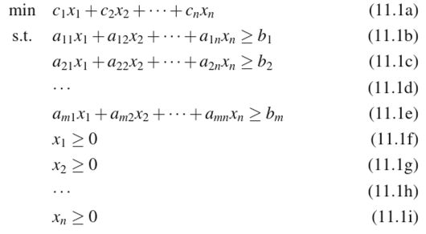

**General Formula to Maximize**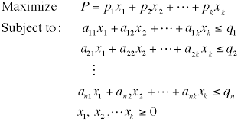

Some terminologies used in Linear Programming are given below-

* **Decision Variables:** The decision variables are the variables that will decide the output. They represent the ultimate solution. To solve any problem, we first need to identify the decision variables.
* **Objective Function:** It is defined as the objective of making decisions. For example, any company wishes to increase the total profit represented by Z. So, profit is the objective function.
* **Constraints:** The constraints are the restrictions or limitations on the decision variables. They usually limit the value of the decision variables. For example, the limit on the availability of resources like labour are constraints.
* **Non-negativity restriction:** For all linear programs, the decision variables should always take non-negative values. This means the values for decision variables should be greater than or equal to 0.

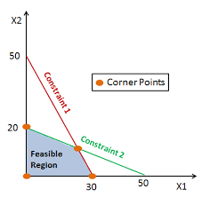

**HISTORY**

The problem of solving a system of linear inequalities dates back at least as far as Fourier, who in 1827 published a method for solving them and after whom the method of Fourier–Motzkin elimination is named. Applications of the method of linear programming were first seriously attempted in the late 1930s by the Soviet mathematician Leonid Kantorovich and by the American economist Wassily Leontief in the areas of manufacturing schedules and of economics, respectively, but their work was ignored for decades. During World War II, linear programming was used extensively to deal with transportation, scheduling, and allocation of resources subject to certain restrictions such as costs and availability. During 1946–1947, George B. Dantzig independently developed general linear programming formulation to use for planning problems in the US Air Force. In 1947, Dantzig also invented the simplex method that for the first time efficiently tackled the linear programming problem in most cases. When Dantzig arranged a meeting with John von Neumann to discuss his simplex method, Neumann immediately conjectured the theory of duality by realizing that the problem he had been working in game theory was equivalent. Dantzig provided formal proof in an unpublished report "A Theorem on Linear Inequalities" on January 5, 1948. Dantzig's work was made available to public in 1951. In the post-war years, many industries applied it in their daily planning.

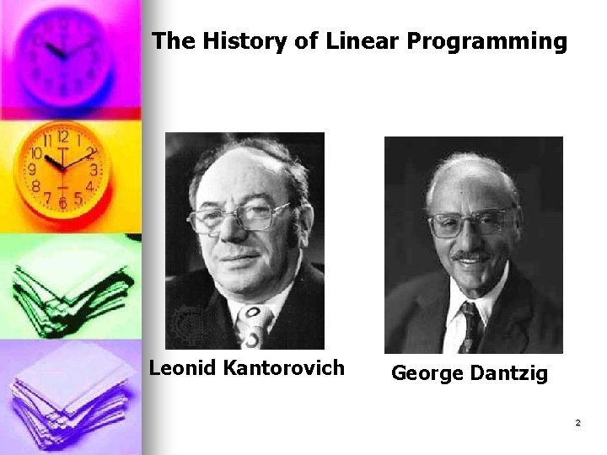

However, as increasingly more complex problems involving more variables were attempted, the number of necessary operations expanded exponentially and exceeded the computational capacity of even the most powerful computers. Then, in 1979, the Russian mathematician Leonid Khachiyan discovered a polynomial-time algorithm—in which the number of computational steps grows as a power of the number of variables rather than exponentially—thereby allowing the solution of hitherto inaccessible problems.



However, Khachiyan’s algorithm (called the ellipsoid method) was slower than the simplex method when practically applied. In 1984 Indian mathematician Narendra Karmarkar discovered another polynomial-time algorithm, the interior point method, that proved competitive with the simplex method.



**APPLICATIONS**

**LINEAR OPTIMIZATION IN CONSTRUCTION PROJECT**

Construction planning is a fundamental and challenging activity in the management and execution of construction projects. The choice of technology, the definition of work tasks, the estimation of the required resources and durations for individual tasks, and the identification of any interactions among the different work tasks are very important. A good construction plan is the basis for developing the budget and the schedule for work. Developing the construction plan is a critical task in the management of construction, even if the plan is not written or otherwise formally recorded. The building construction project usually divided into three major works. These are as follows in a sequential manner.

* Civil works
  + Foundation Up-to PL
  + Superstructure Works
* Sanitary and water supply works
* Internal electrical works

In this project the projected total Budget is Rs. 3962700.

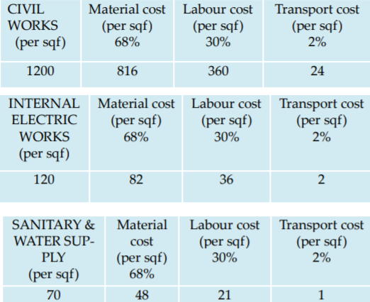

To complete maximum work in our limited budget. a constructing building starting its work with limited budget. after completing design and foundation work, we have 2 crore to complete the work. Using two variable x1, x2. x1 represents civil works (per floor) and x2 represents Internal electric work, sanitary & water supply work (per apartment). Three types of cost calculate here. Material cost, labour cost and transport cost. we divide our amount as total material cost never to exceed Rs. 14000000, total labour cost never to exceed Rs. 5600000 and total transport cost never to exceed Rs. 400000. Civil work means completing ceiling, pillar, door, window and colour. For civil work the material cost (per floor) is 2496960, labour cost (per floor) is 1101600, transport cost (per floor) is 73440 and for internal electric work, sanitary & water supply work the material cost (per apartment) is 198900, labour cost (per apartment) is 8721, transport cost (per apartment) is 4590.

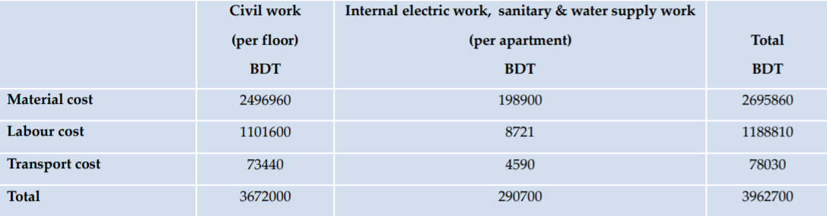

For our required constructing building, our plot size is ten katha.

1 katha = 720 sqf

So, 10 katha = 7200 sqf

We will use 57.5% area of the total area which is, 4140 sqf. We can use maximum 4140 sqf area out of 7200 sqf for the constructing project.

FAR means Floor Area Ratio which must be 4.25. If we want to construct 10 floors, then we can use 3060 sqf per floor out of 4140 sqf. Each floor containstwo apartments and each apartment area is (3060/2) = 1530 sqf.

Maximize: 3672000 x1+ 290700 x2

Subject to the constraints,

2496960 x1 + 198900 x2 ≤ 14000000

1101600 x1 + 87210 x2 ≤ 5600000

73440 x1 + 4590 x2 ≤ 400000

x1 ≤ 10

-2 x1 + x2 ≤ -2

x1, x2 ≥ 0

Introducing slack variables

Maximize: 3672000 x1 + 290700 x2

Subject to the constraints,

2496960 x1 + 198900 x2 + s1 = 14000000

1101600 x1 +87210 x2 + s2 = 5600000

73440 x1 + 4590 x2 + s3 = 400000

x1 + s4 = 10

-2 x1 + x2+ s5 = -2

x1, x2, s1, s2, s3, s4, s5 ≥ 0

where s1, s2, s3, s4, s5 are slack variables.

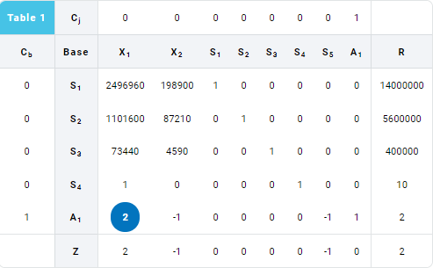

Iteration 1

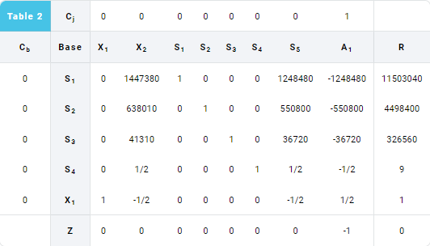

New Tableu

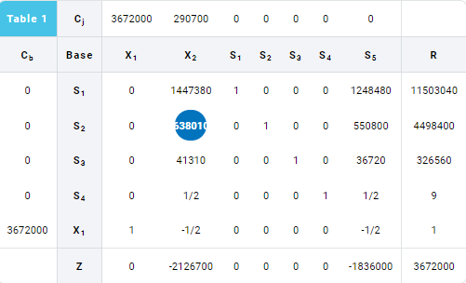

Iteration 1

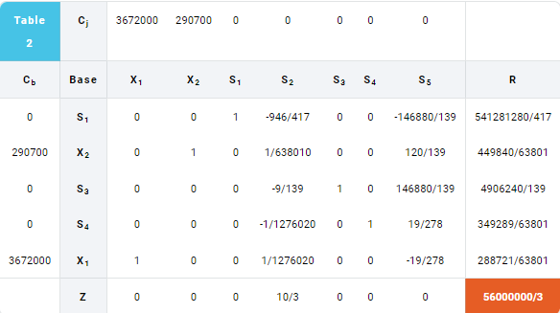

**LINEAR OPTIMIZATION IN MANUFACTURING**

The main objective is to maximize the profit of a Pharma company in the area of manufacturing and minimize the cost of transportation of Cough syrup to transport from different plants of company situated at different location to different customers situated at different locations. We apply linear programming technique to maximize profit and minimize transportation cost.

We make the following assumptions

* The total ingredients used is fixed.
* The total demand of medicine is fixed.
* There is a linear relationship among the variables used in the problem.

The company has following constraints:

* The total number of packets of medicine type A (50 gm) is not more than 400.
* The total number of packets of medicine type B (100 gm) is not more than 200.
* The total number of packets of medicine both type is not more than 450.
* The time available for packing of type A medicine is 1 hours for 100 packets and for packing of type B medicine is 3 hours for 100 packets.
* The total man hours used for packing of both type medicine is not more than 10 hours.
* The profit for each packet of type A is Rs. 27 and for each packet of type B is Rs. 48.

|  |  |  |  |
| --- | --- | --- | --- |
| Ingredients | Used ingredients (in gm) per packet | | Available Ingredients |
| A (50 g packet) | B (100 g Packet) |
| Bala extract | 12.5 | 25 | 10000 |
| Madhu vasant | 2 | 4 | 1500 |
| Pushp | 2 | 4 | 1400 |
| Madhu extract | 3 | 6 | 1500 |
| Kam ras | 2.5 | 5 | 1350 |
| Vati | 2.5 | 5 | 1200 |
| Amalki | 5 | 10 | 2800 |
| Arjun extract | 2.5 | 5 | 2600 |
| Pipal extract | 2.5 | 5 | 1100 |
| Abhrak | 0.5 | 1 | 300 |
| Shatawari | 15 | 30 | 8250 |
| Profit (Rs.) | 27 | 48 |  |

Let number of packets of type A = u1

Let number of packets of type B = u2

Let Z represent the total profit to be maximize.

The linear programming problem for the above data is given by

Maximize Z = 27 u1 + 48 u2

Subject to

12.50 u1 + 25 u2 ≤ 10000

2 u1 + 4 u2 ≤ 1500

2 u1 + 4 u2 ≤ 1400

3 u1 + 6 u2 ≤ 1500

2.5 u1 + 5 u2 ≤ 1350

2.5 u1 + 5 u2 ≤ 1200

5 u1 + 10 u2 ≤ 2800

2.5 u1 + 5 u2 ≤ 2600

2.5 u1 + 5 u2 ≤ 1100

0.5 u1 + u2 ≤ 300

15 u1 + 30 u2 ≤ 8250

u1 + u2 ≤ 450

u1 + 3 u2 ≤ 1000

u1 ≤ 400

u2 ≤ 200

u1, u2 ≥ 0

Using slack variables and simplify, the problem converted to

12.50 u1 + 25 u2 + s1 = 10000

2 u1 + 4 u2 + s2 = 1500

2 u1 + 4 u2 + s3 = 1400

3 u1 + 6 u2 + s4 = 1500

2.5 u1 + 5 u2 + s5 = 1350

2.5 u1 + 5 u2 + s6 = 1200

5 u1 + 10 u2 + s7 = 2800

2.5 u1 + 5 u2 + s8 = 2600

2.5 u1 + 5 u2 + s9 = 1100

0.5 u1 + u2 + s10 = 300

15 u1 + 30 u2 + s11 = 8250

u1 + u2 + s12 = 450

u1 + 3 u2 + s13 = 1000

u1 + s14 = 400

u2 + s15 = 200

u1, u2, s1, s2, s3, s4, s5, s6, s7, s8, s9, s10, s11, s12, s13, s14, s15 ≥ 0

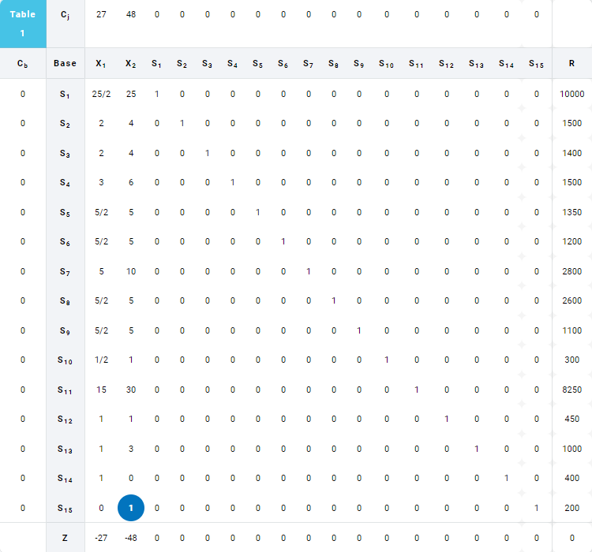

Iteration 1

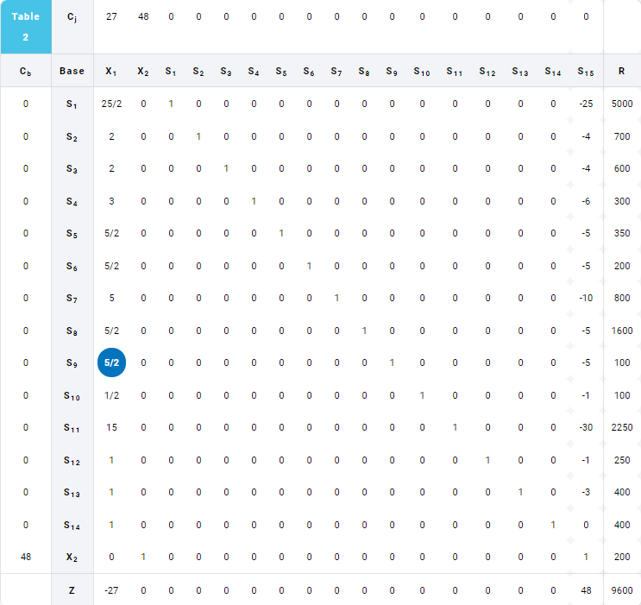

Iteration 2

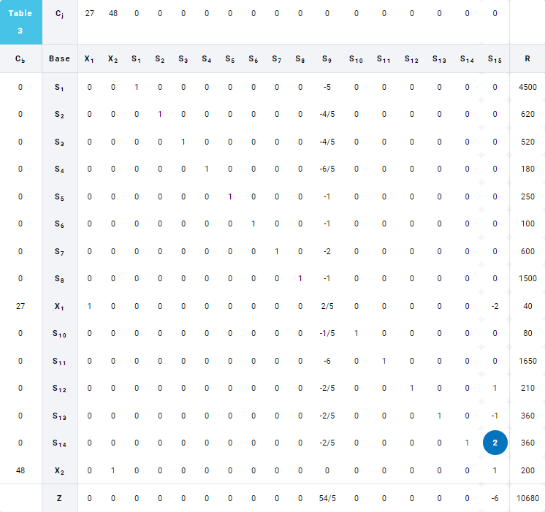

Iteration 3

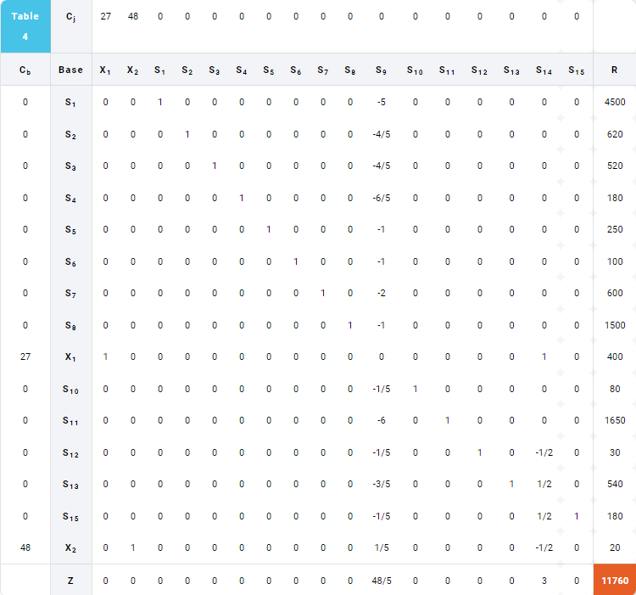

**MATLAB SIMULATIONS**

**I)LINEAR OPTIMIZATION IN CONSTRUCTION PROJECT**

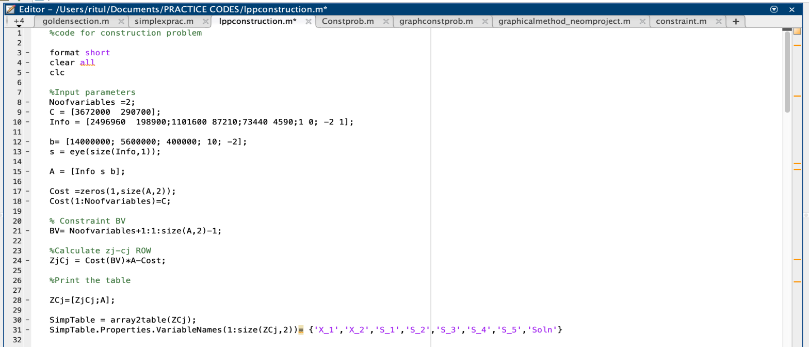**a) Using concepts of simplex method**

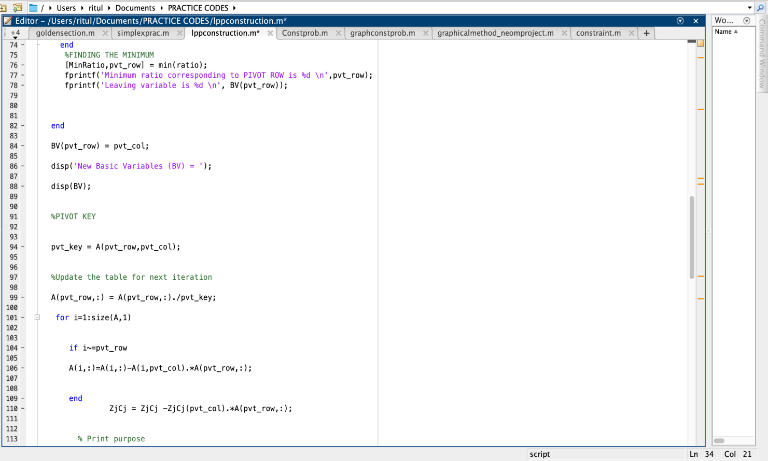

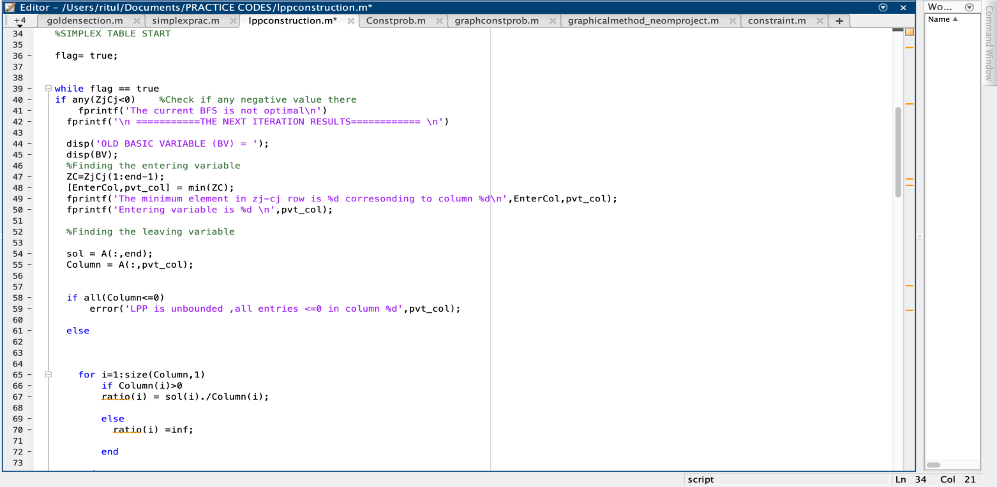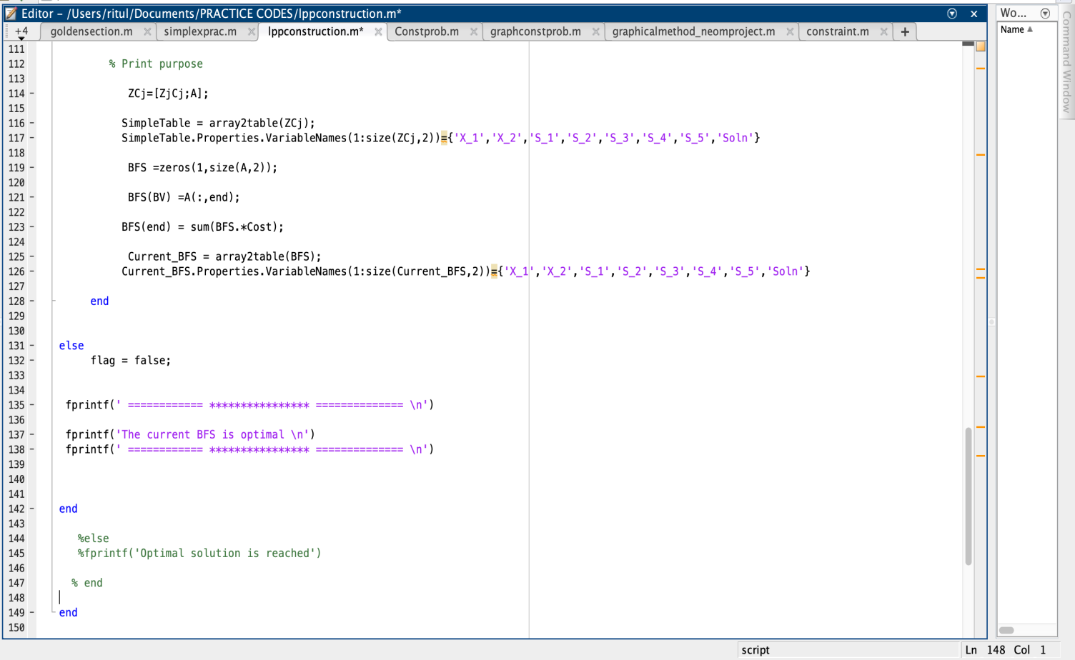

**OUTPUT**

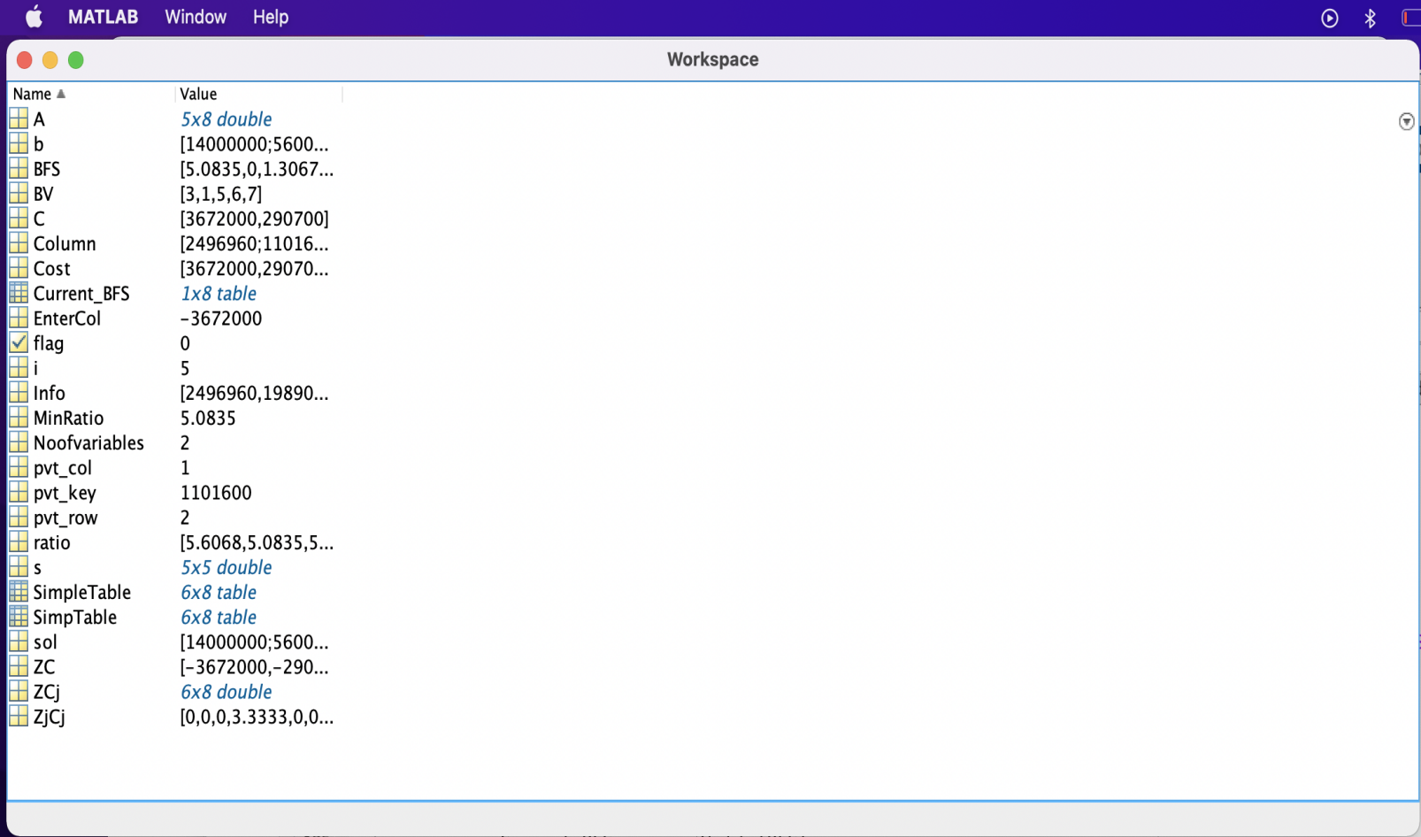**Parameters and variables defined to get the final results-**

**Tableau plotted to get the final optimal solutions with relevant iterations-**

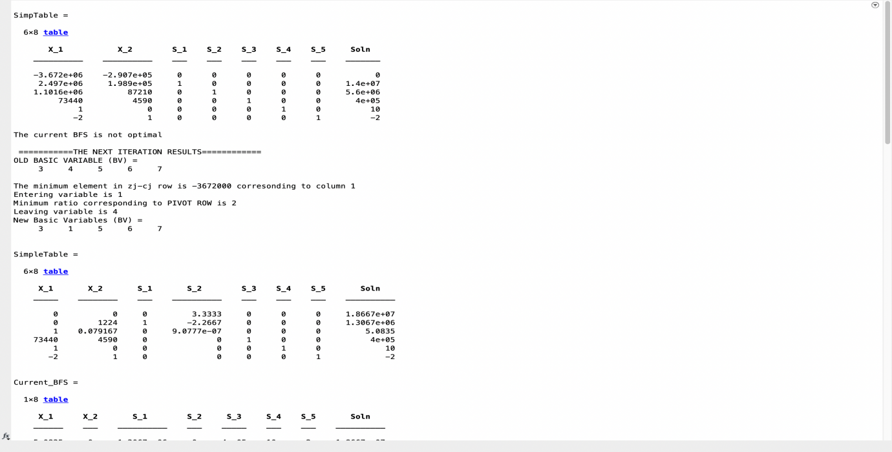

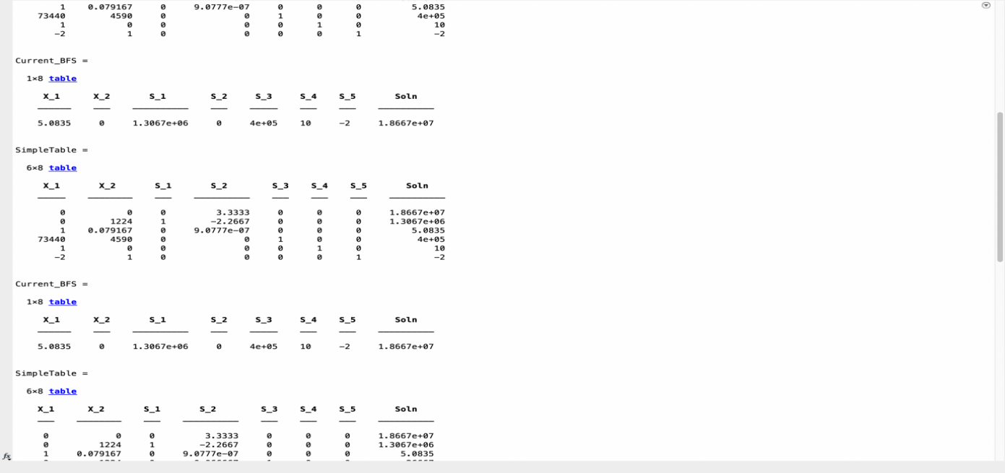

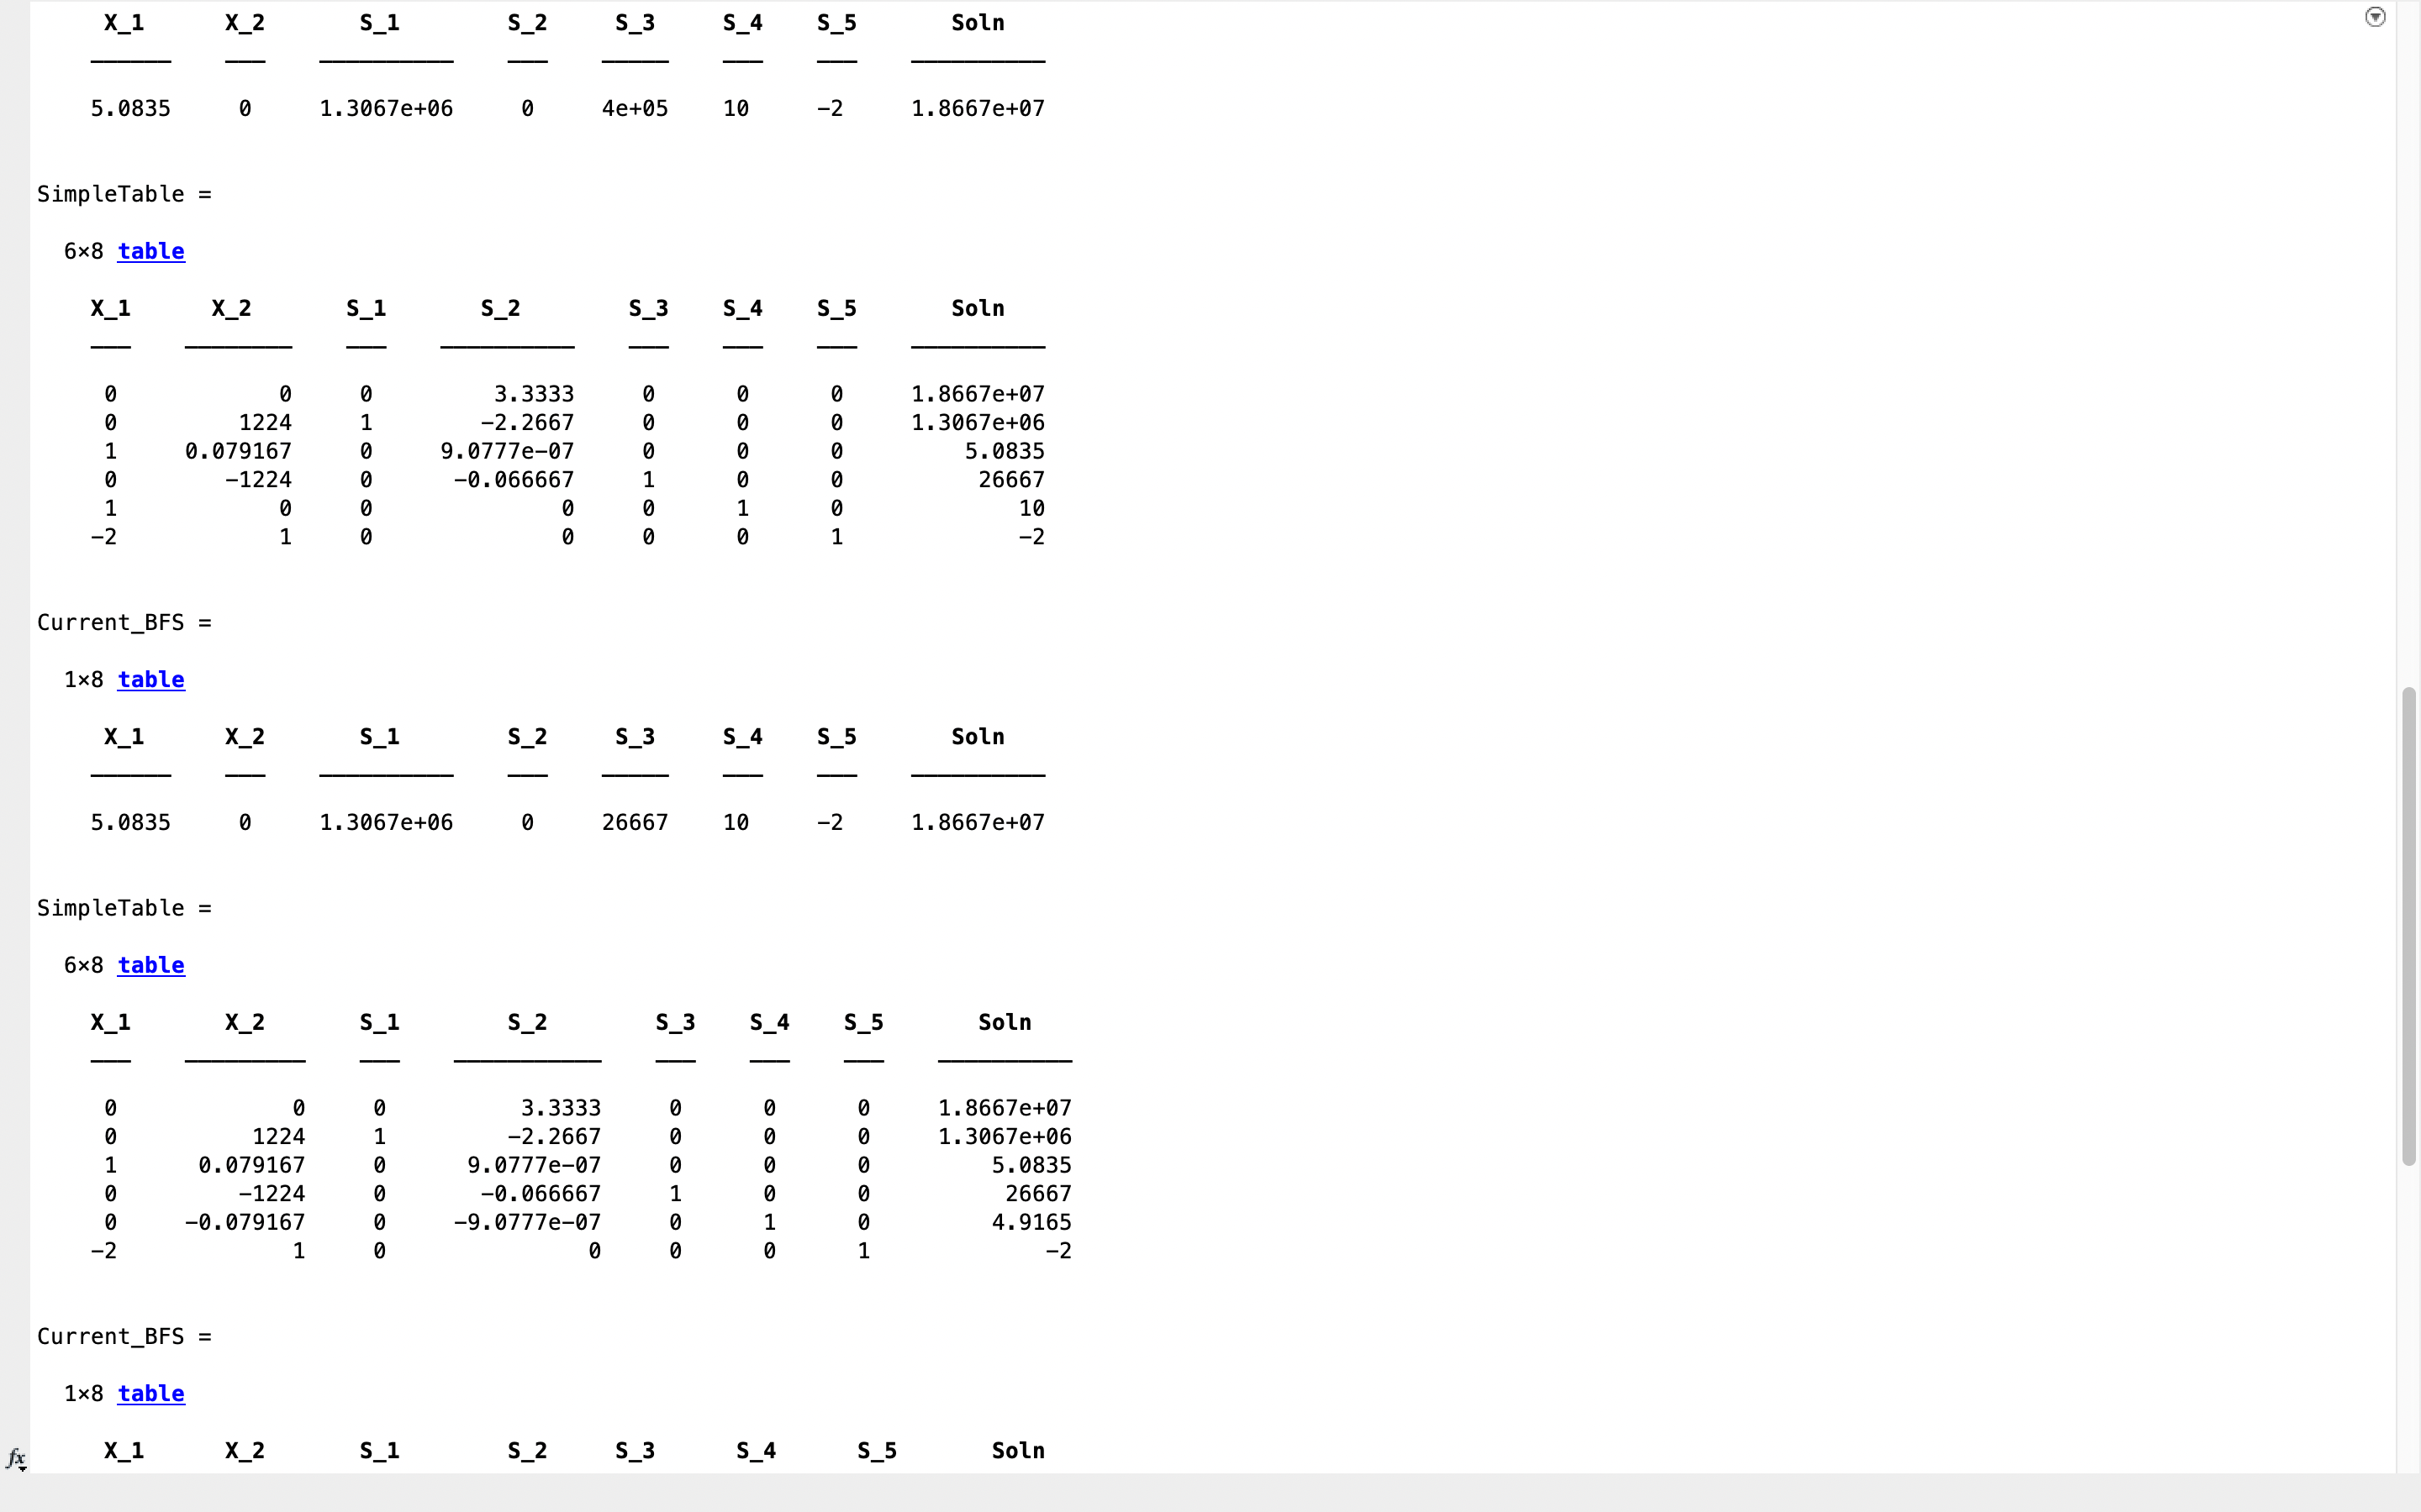



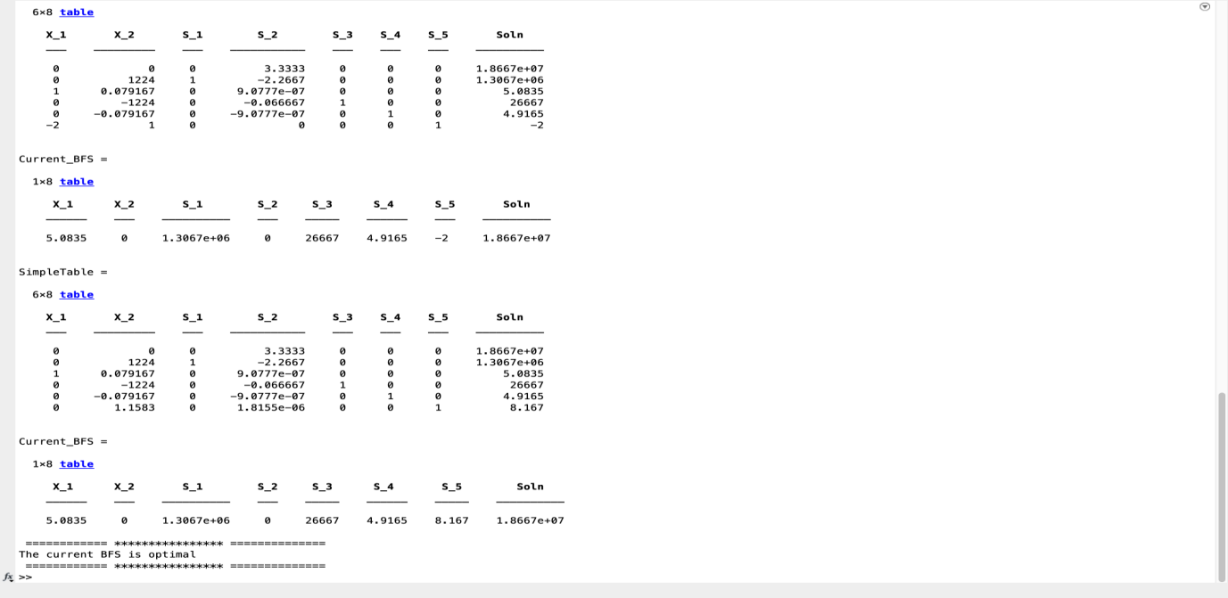

**FINAL OPTIMAL SOLUTION OF THIS CONSTRUCTION PROBLEM**

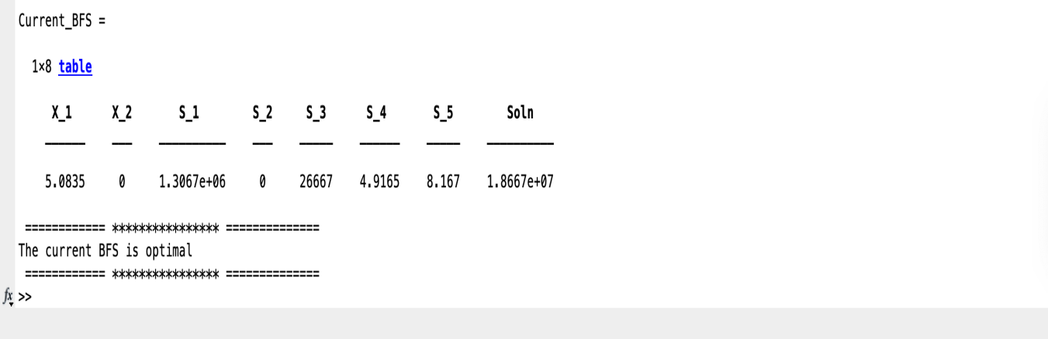

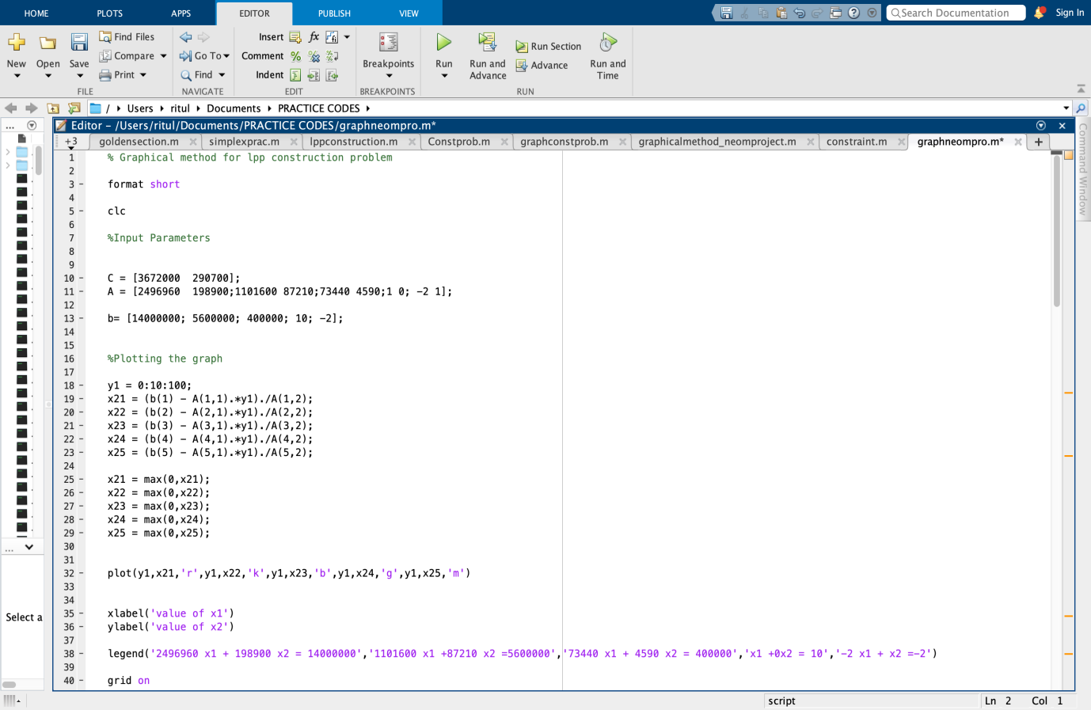**b) Using concepts of graphical method**

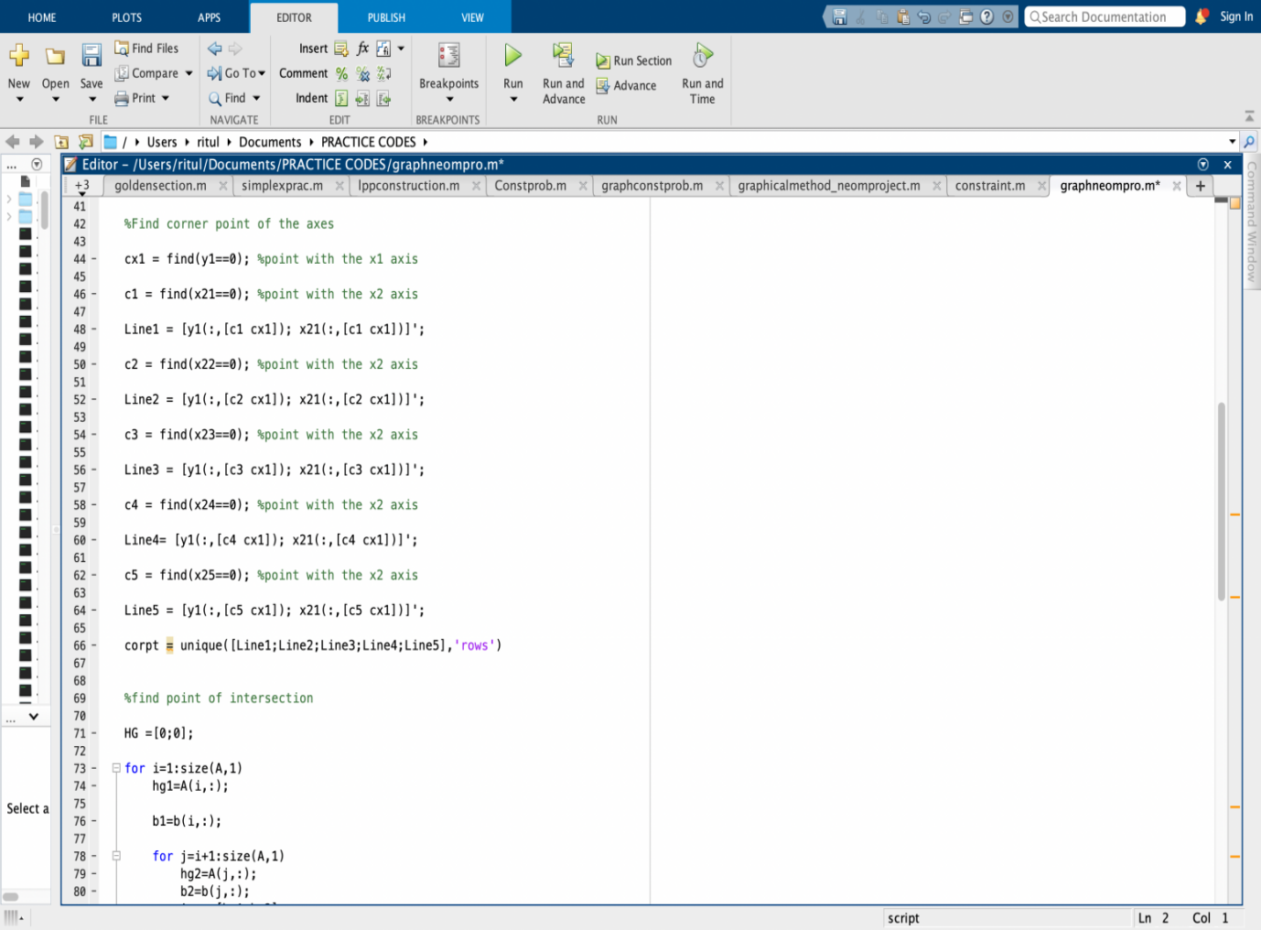

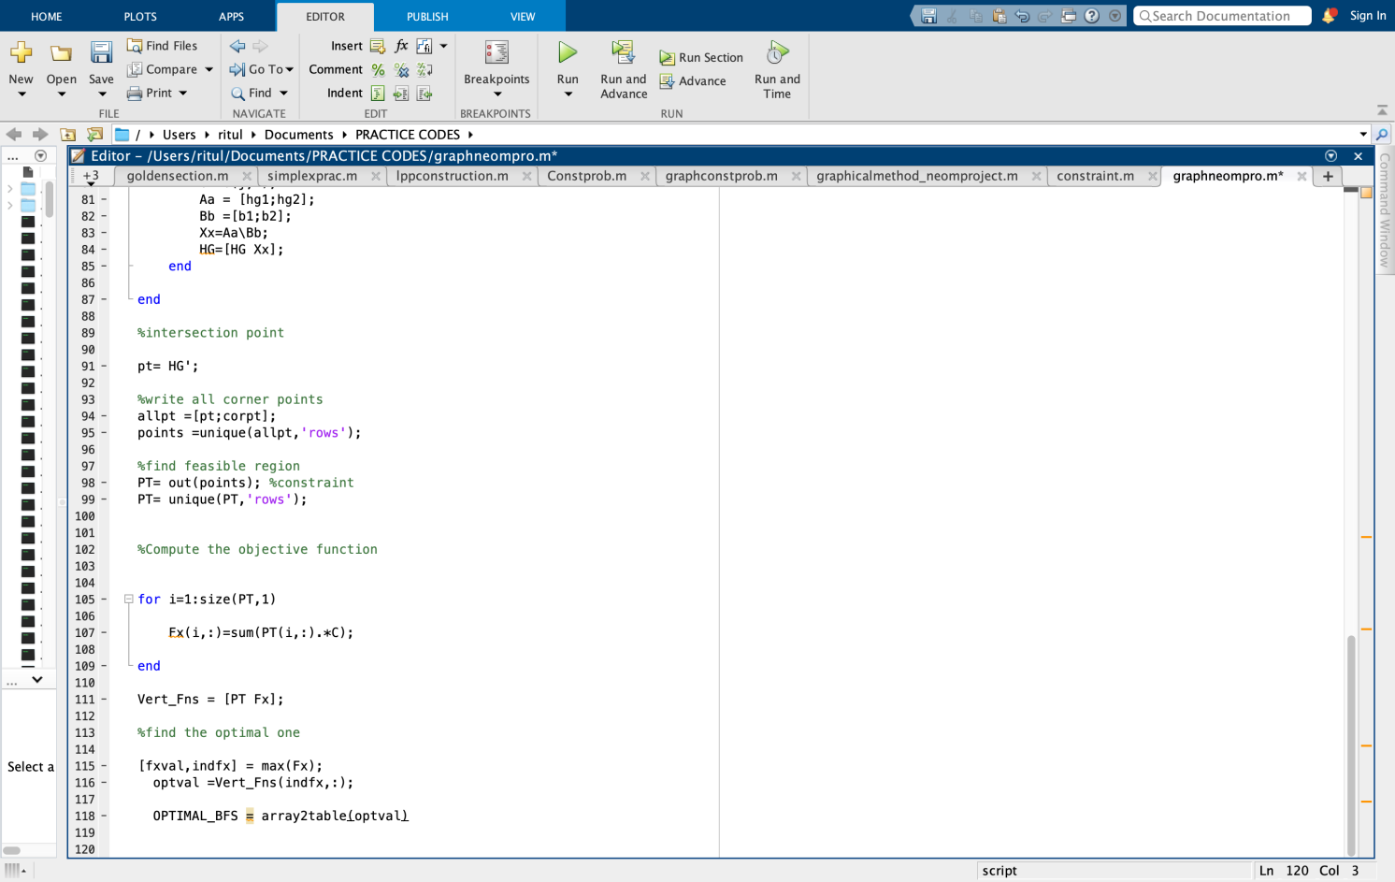A separate function named out.m we created in order to find the feasible region points and discard the points which aren’t in that feasible region as follows-

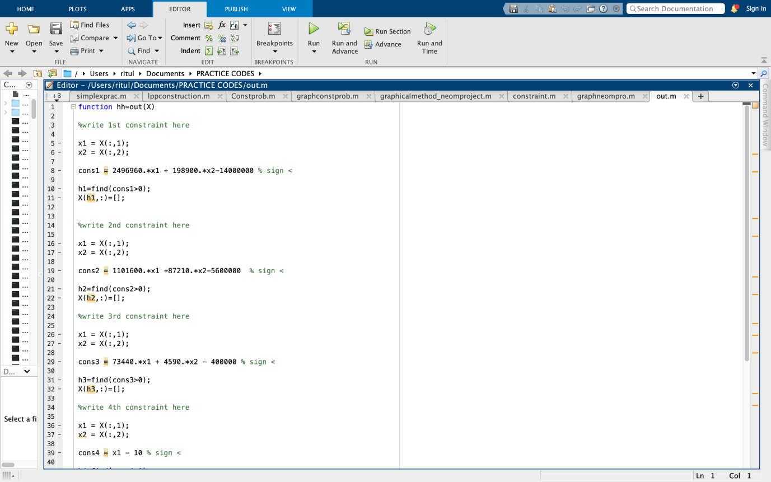

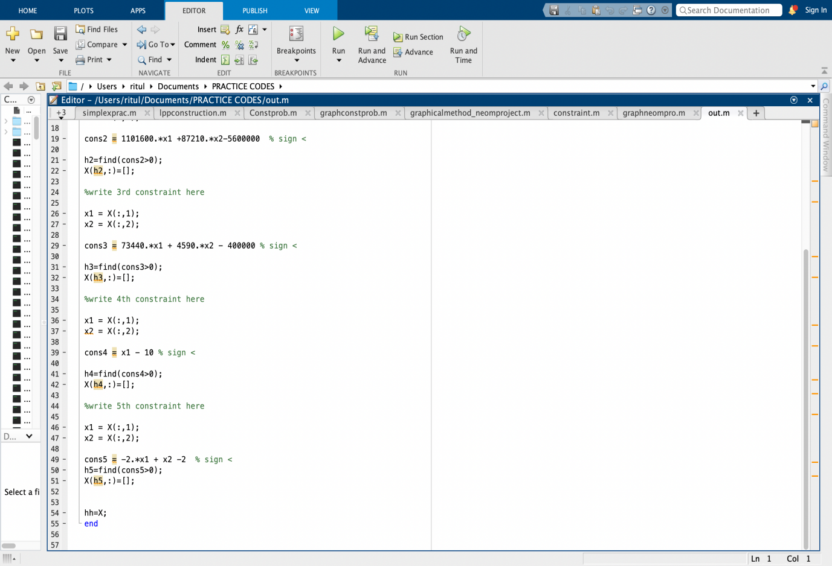

**OUTPUT**

**Parameters and variables defined to get the final results are-**

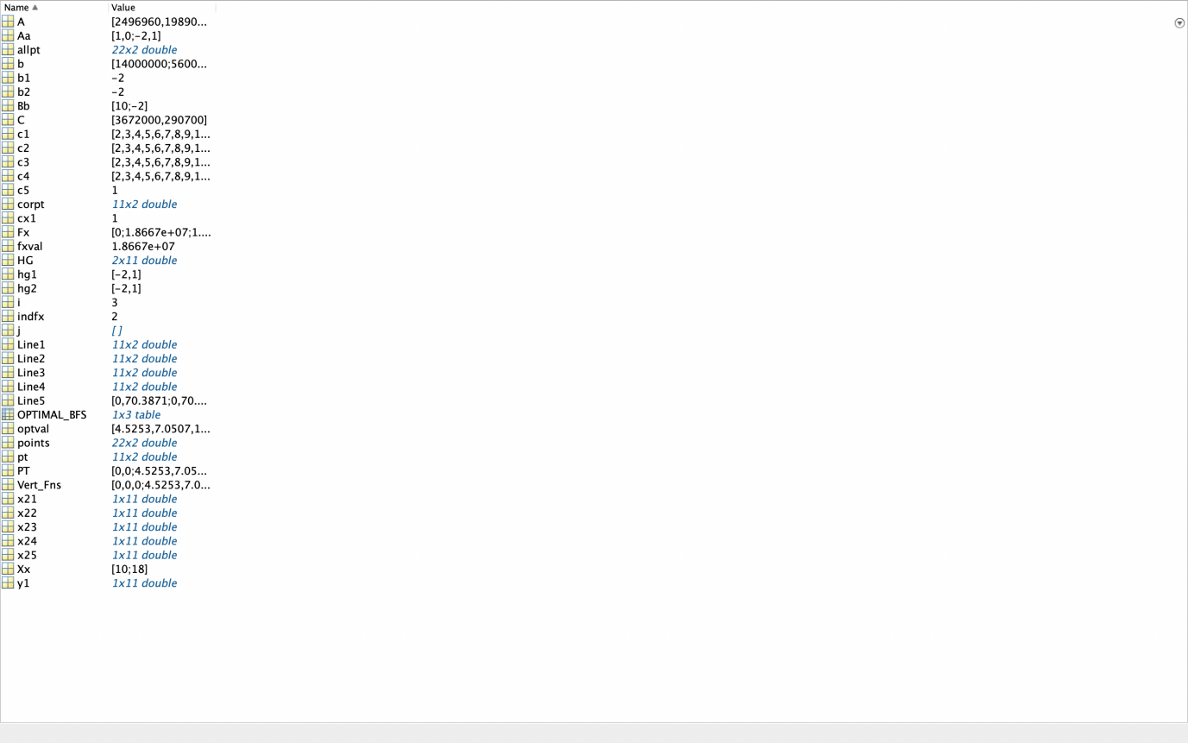

**FINAL OPTIMAL SOLUTION OF THIS CONSTRUCTION PROBLEM**

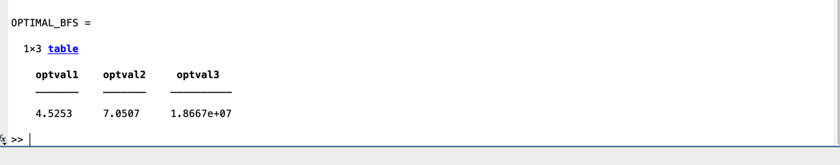

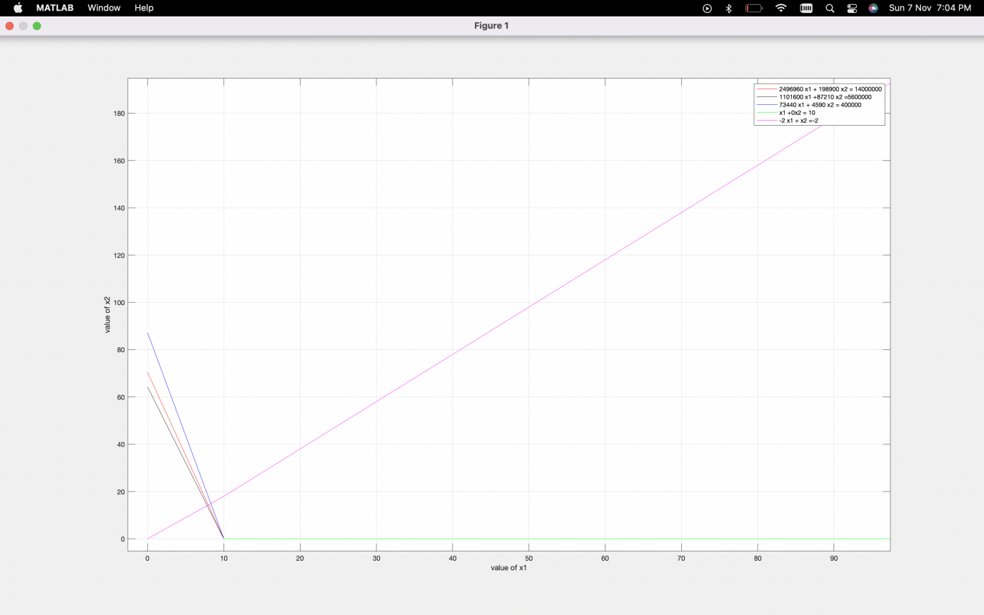**FINAL GRAPHICAL REPRESENTATION**

**II)LINEAR OPTIMIZATION IN MANUFACTURING PROJECT**

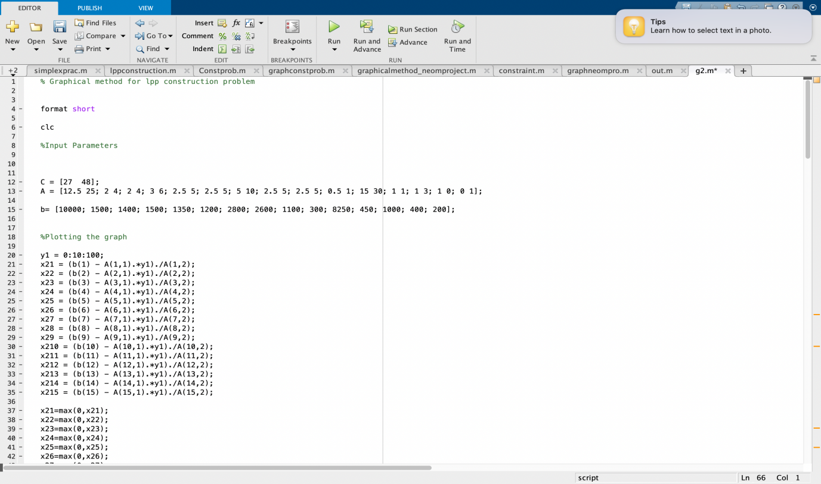**a) Using concepts of graphical method**

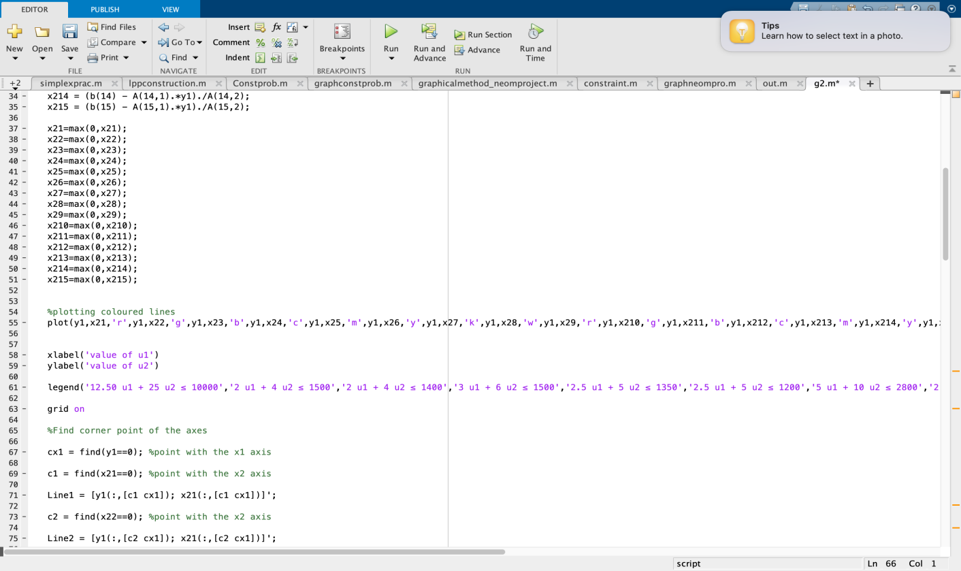

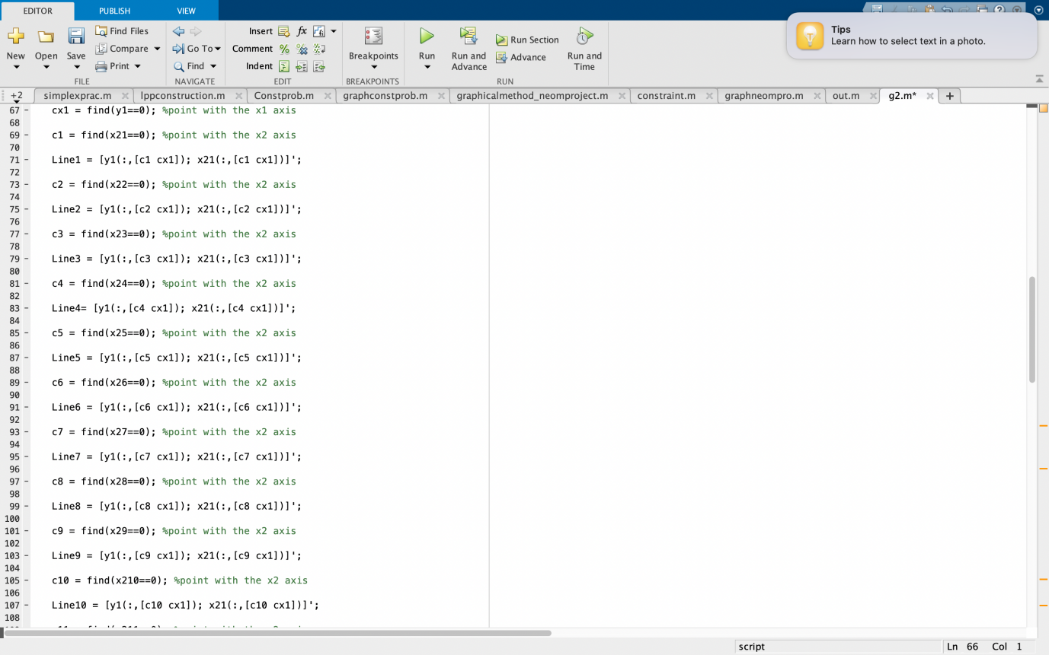

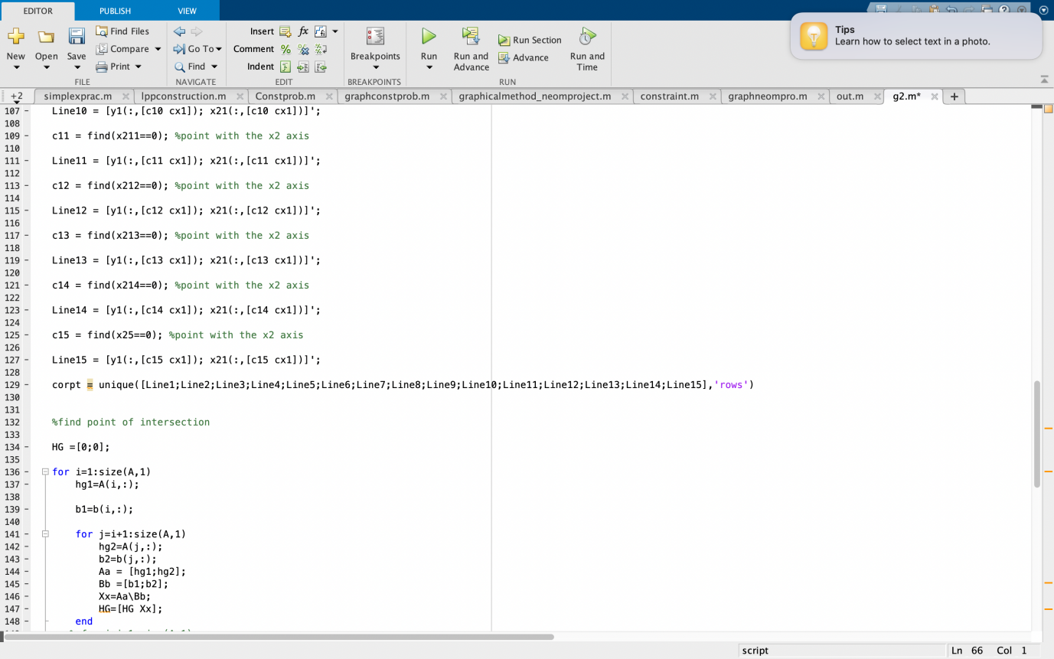

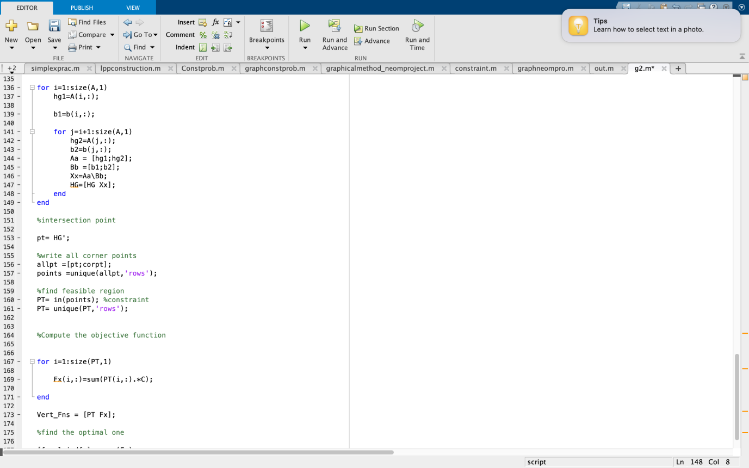

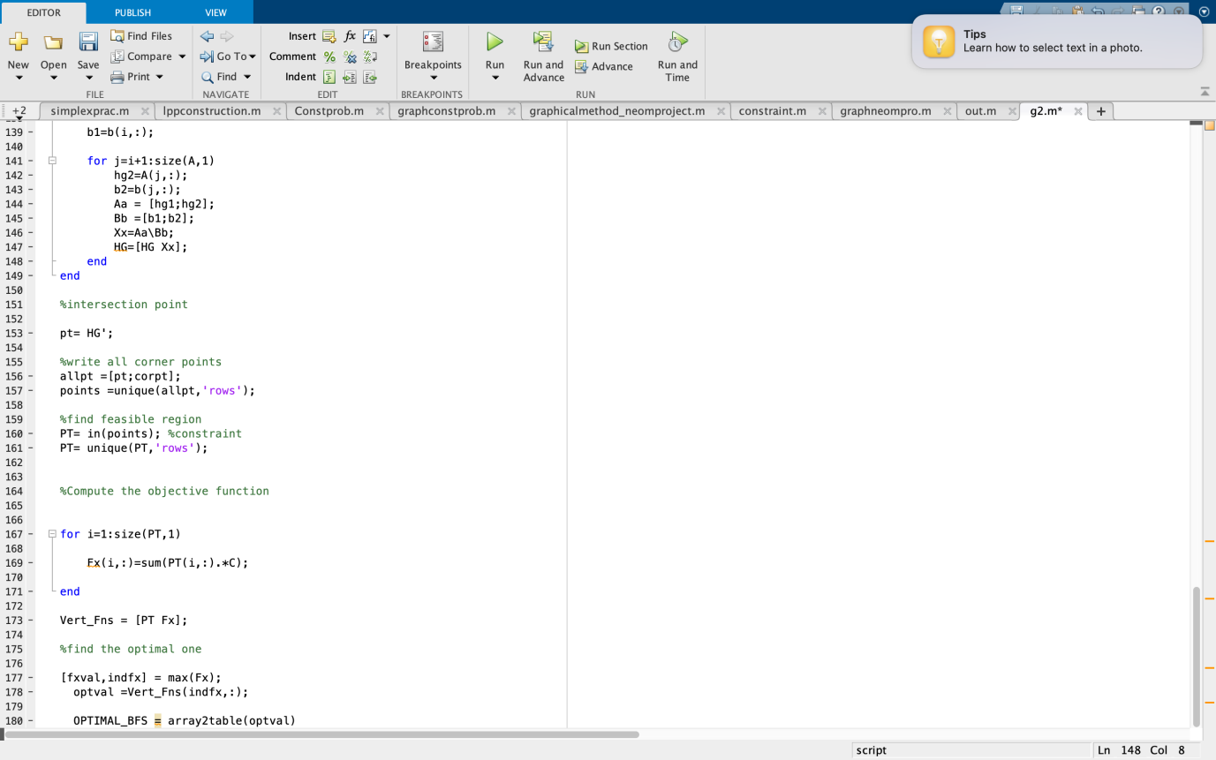

A separate function named in.m we created in order to find the feasible region points and discard the points which aren’t in that feasible region as follows-

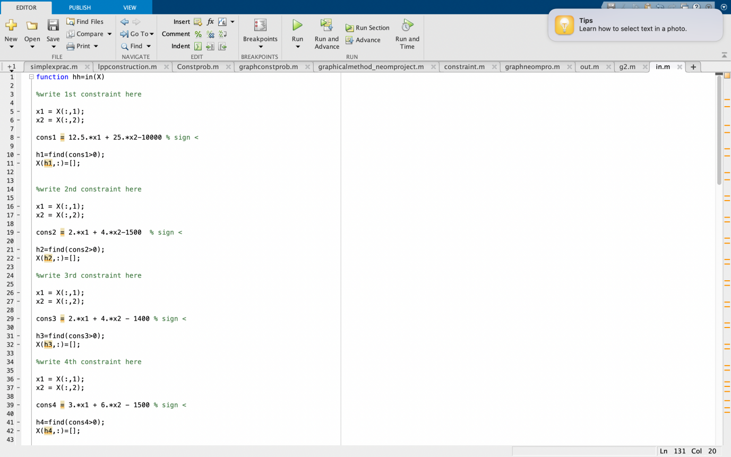

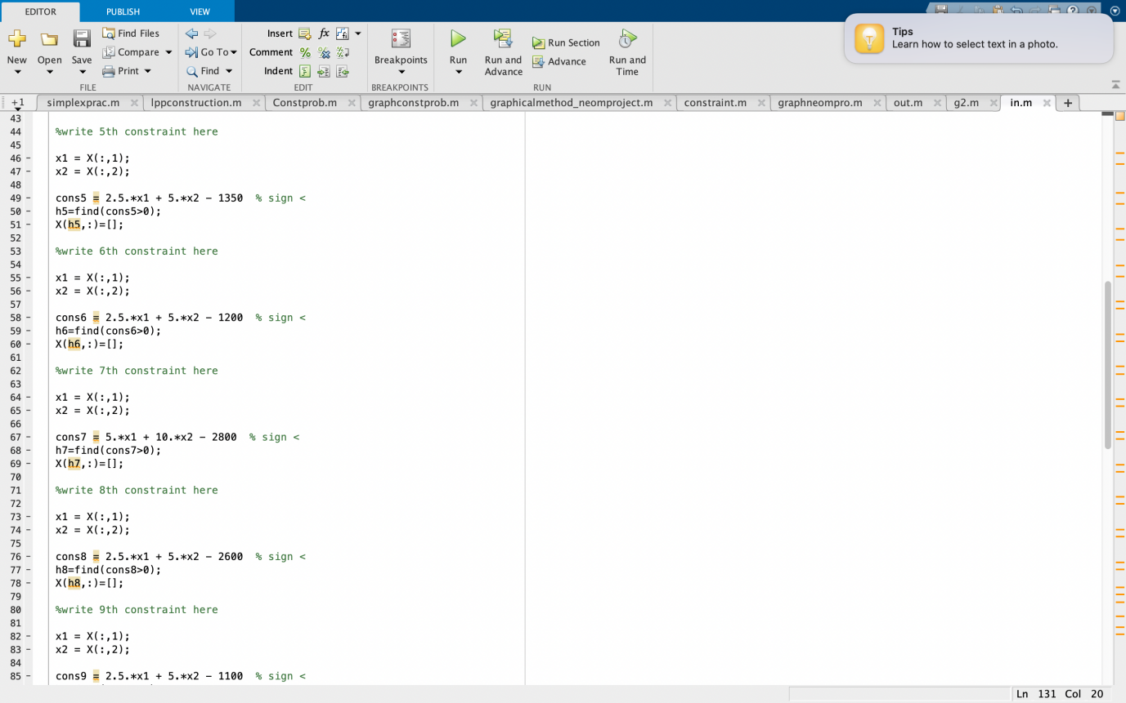

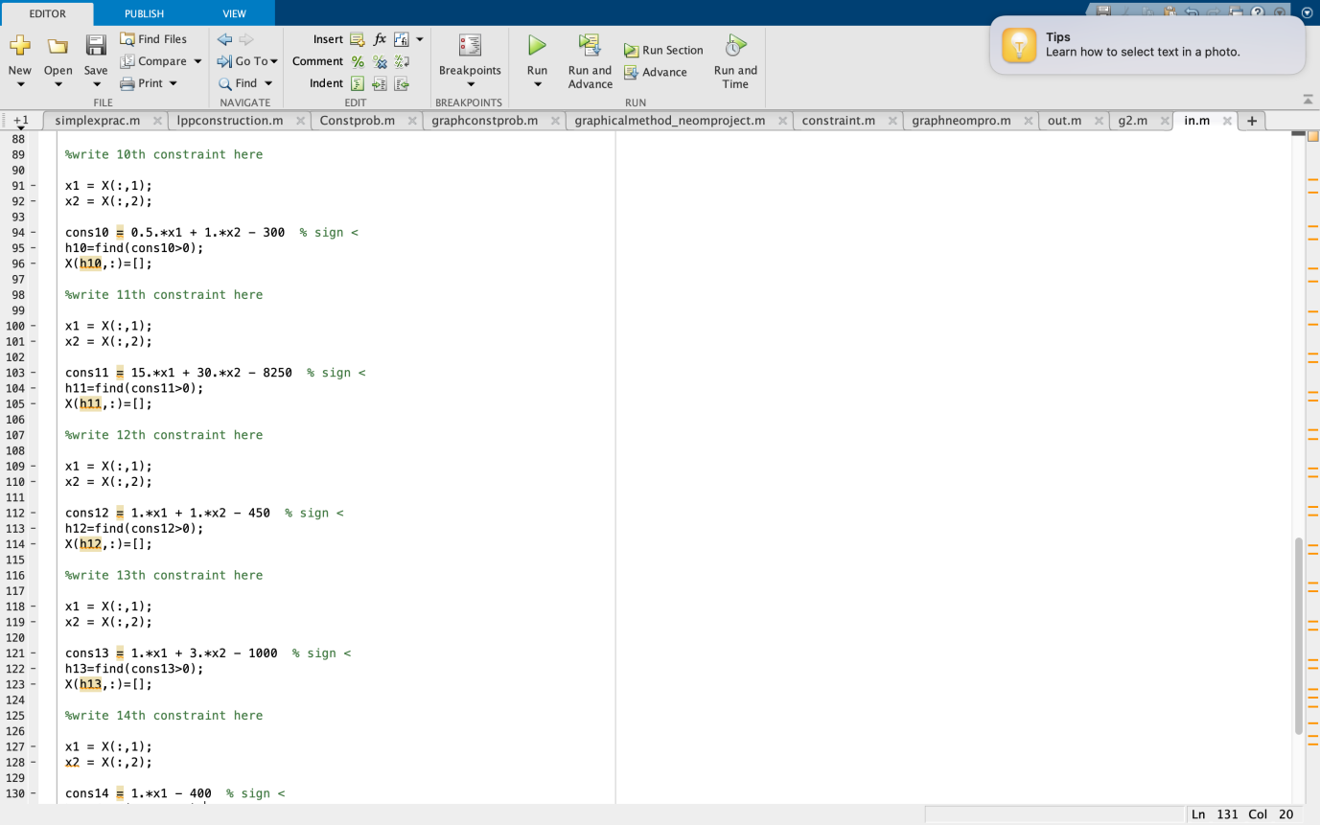

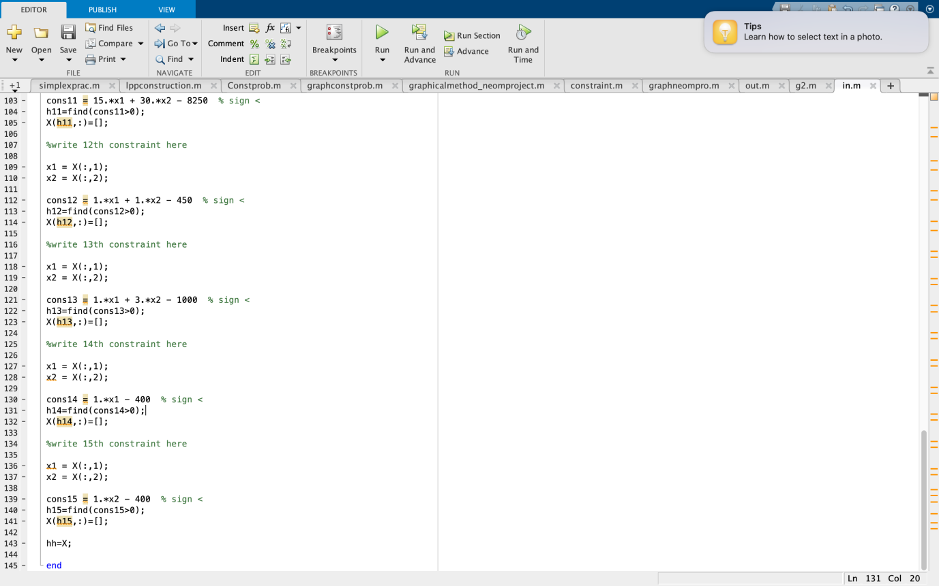

**OUTPUT**

**Parameters and variables defined to get the final results are-**

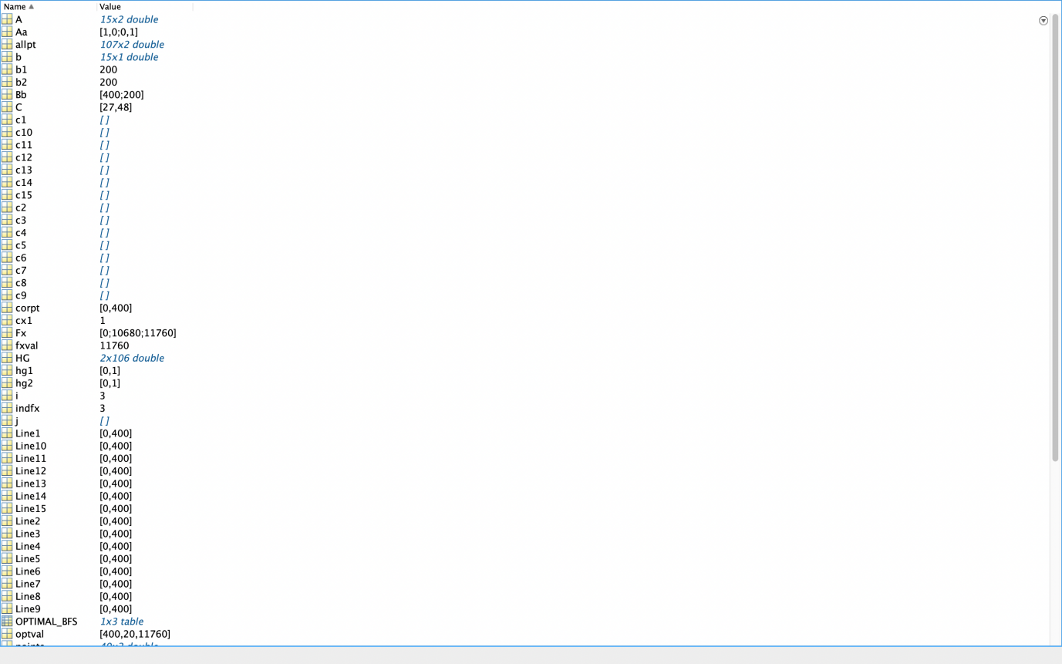

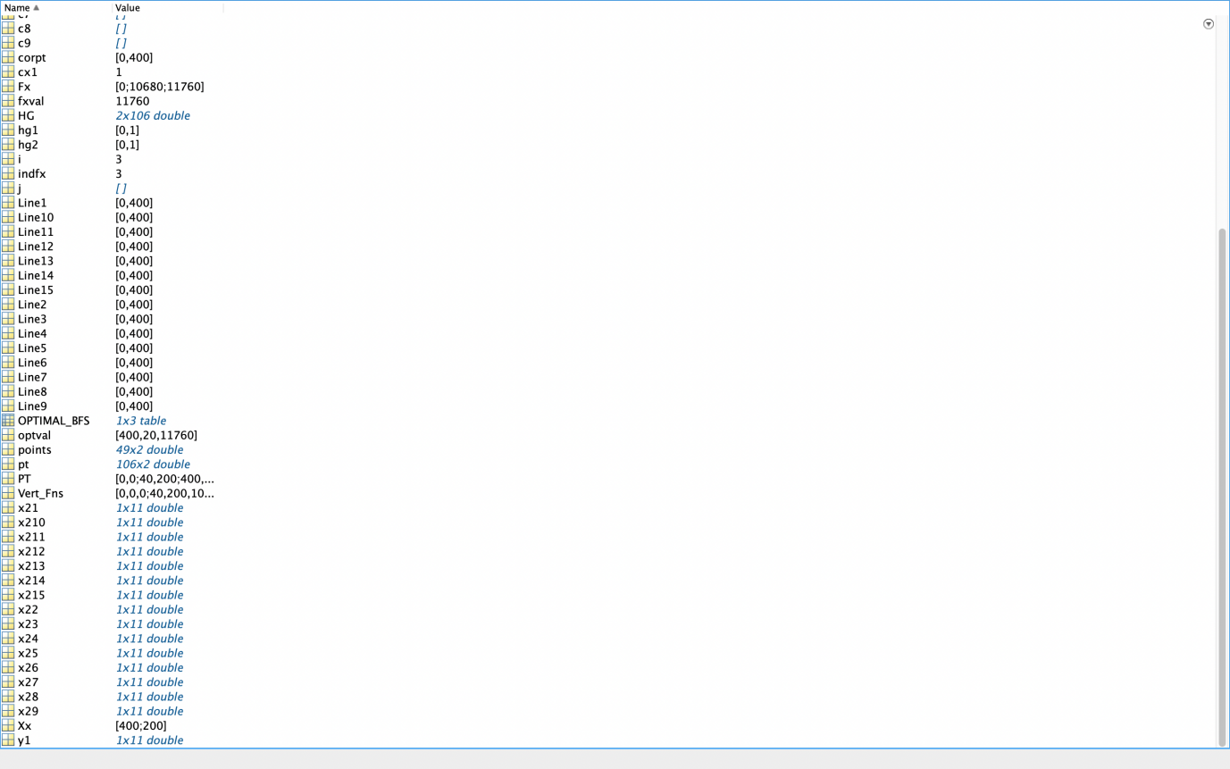

**FINAL OPTIMAL SOLUTION OF THIS CONSTRUCTION PROBLEM**

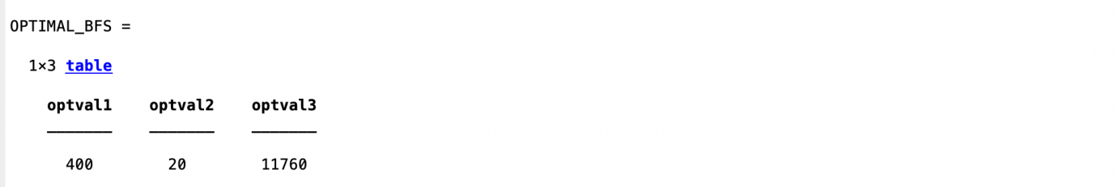

**FINAL GRAPHICAL REPRESENTATION**

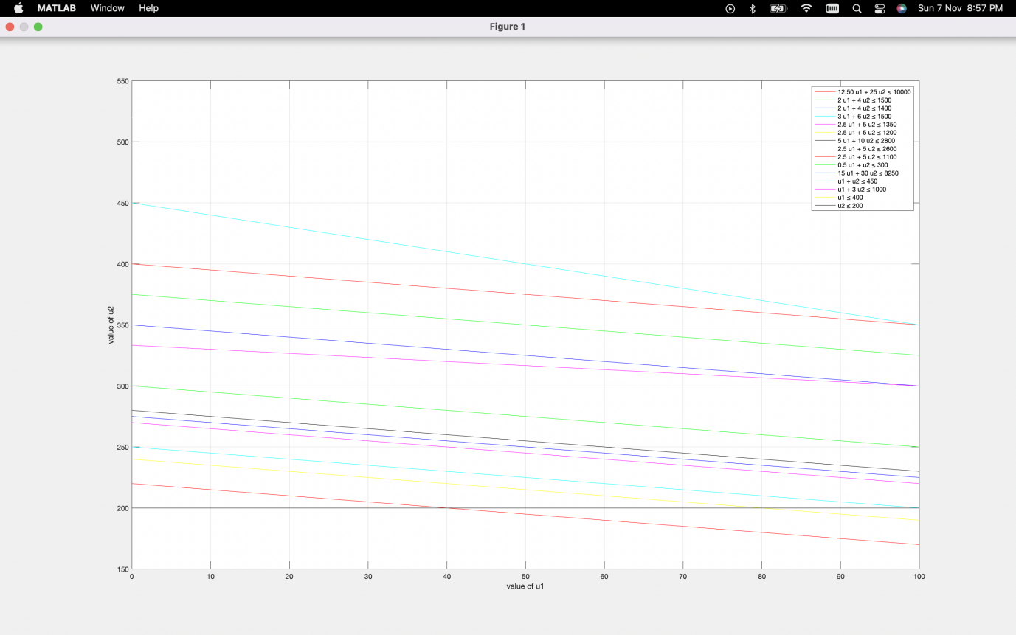

**b) Using concepts of simplex method**

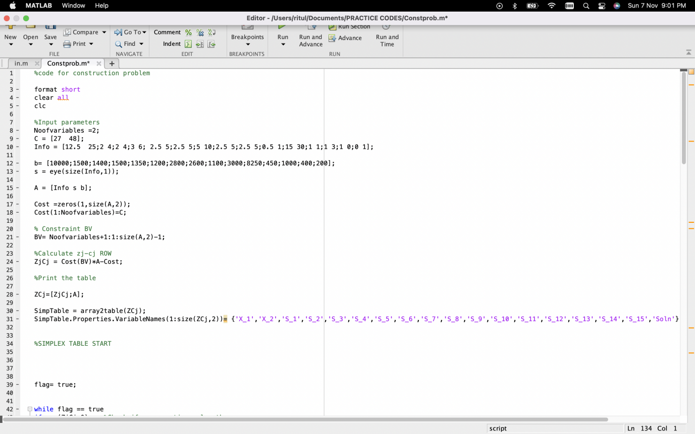

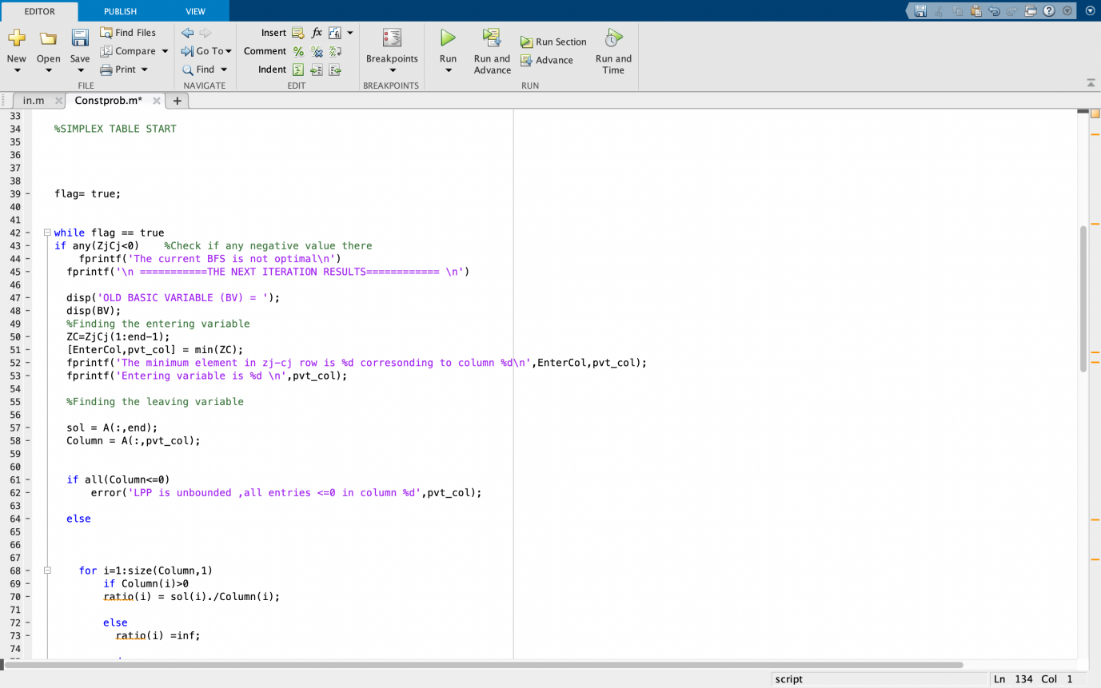

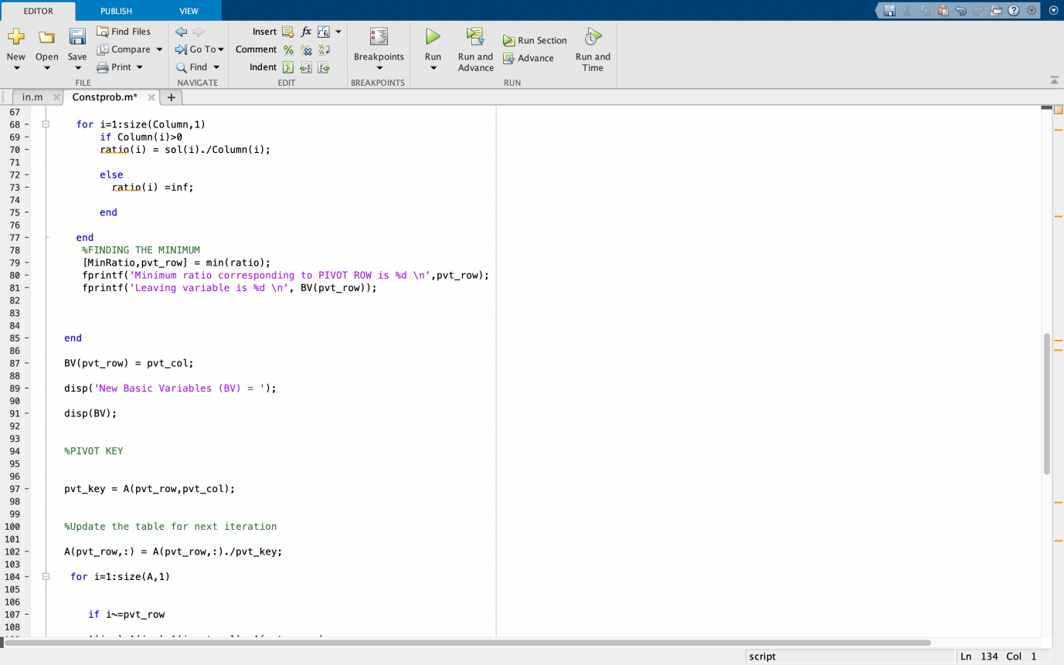

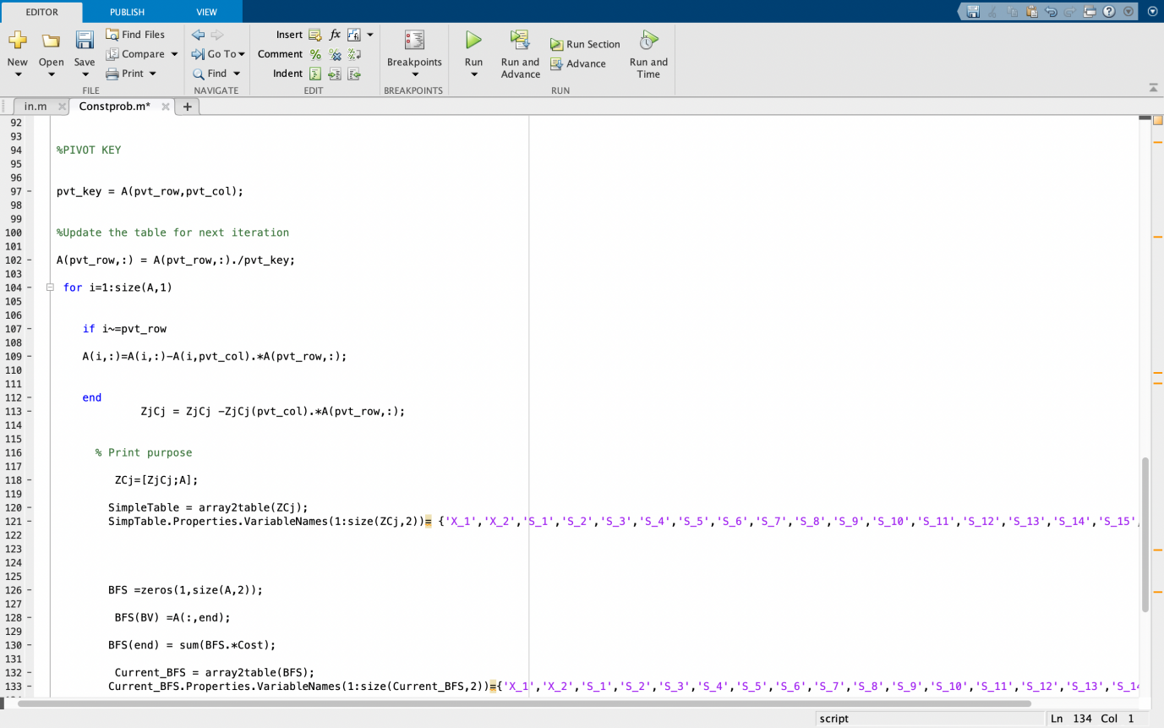

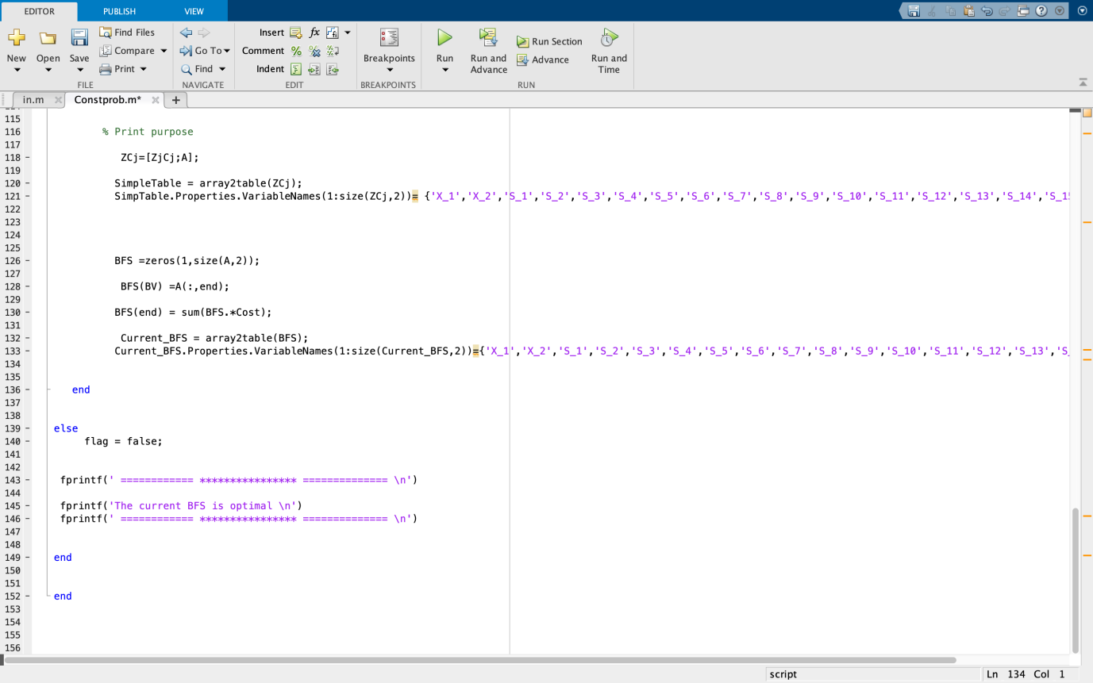

**OUTPUT**

**Parameters and variables defined to get the final results are-**

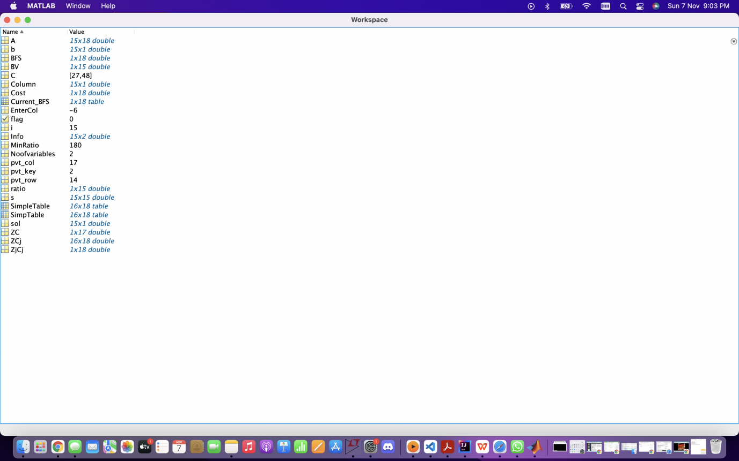

**Tableau plotted to get the final optimal solutions with relevant iterations-**

**Found value for S1to S15 in this case.**

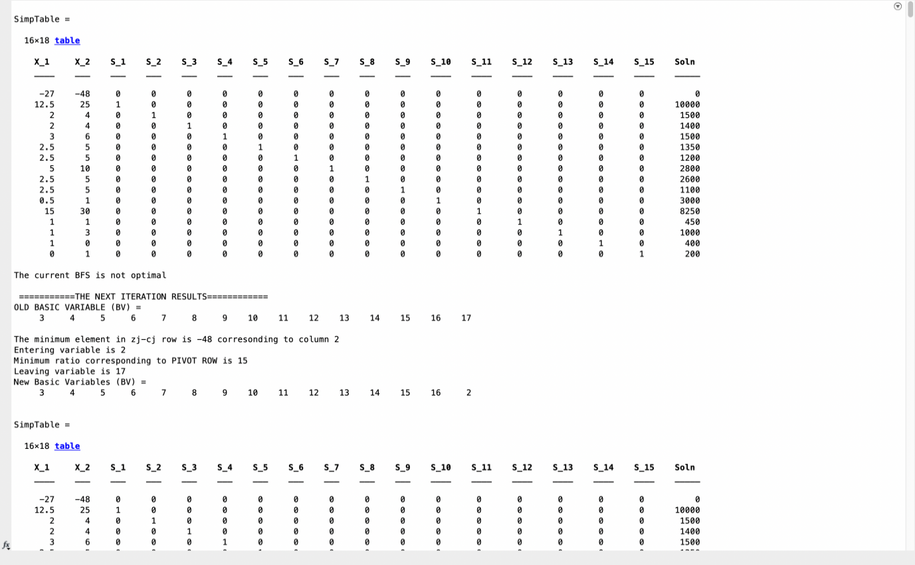

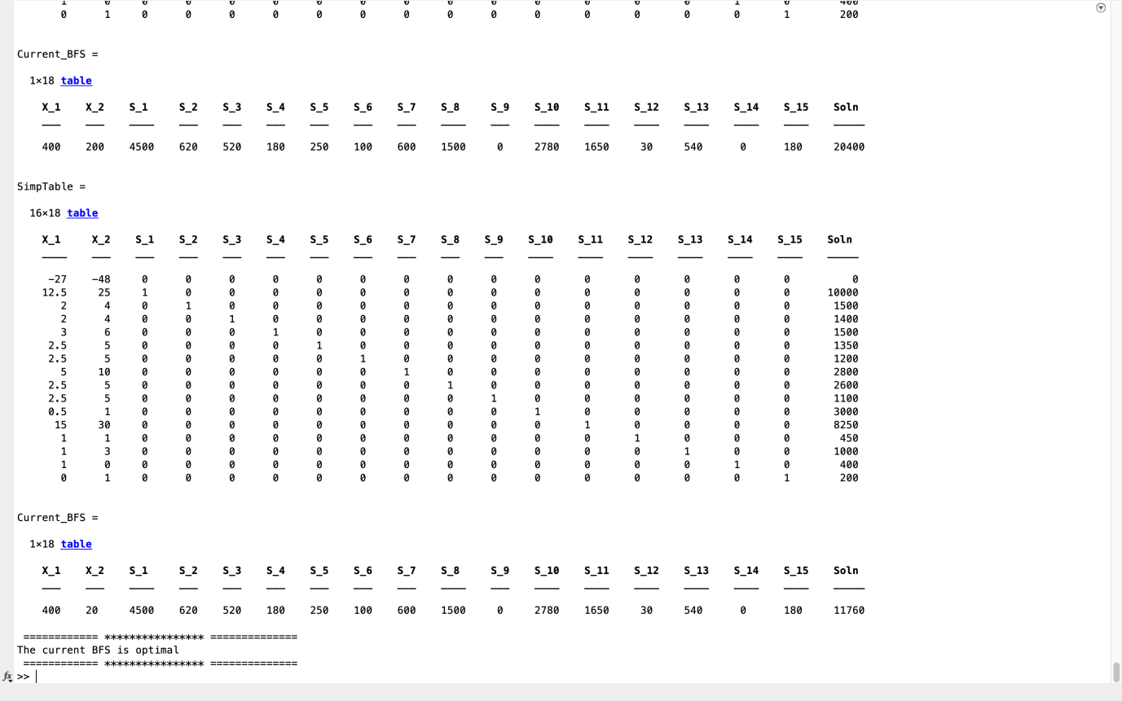

**FINAL OPTIMAL SOLUTION OF THIS MANUFACTURING PROBLEM**

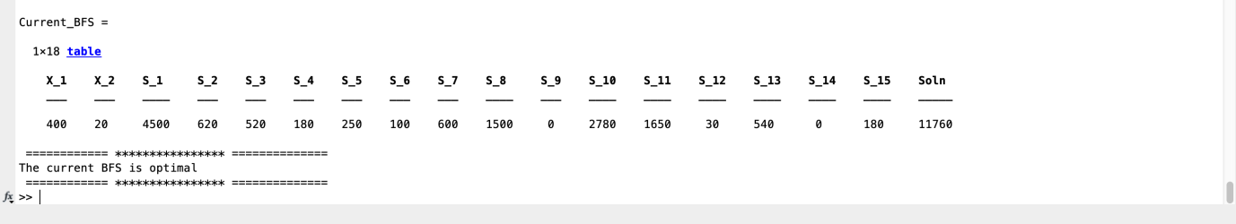

**CONCLUSION**

Maximization is the process by which a constructing project determines the output level that returns the greatest profit. It is the mathematical process of finding the maximum value of a function. Simplex method is the easiest LP solution which usually find a solution quickly. It solves any linear program; It detects unnecessary constraints in the problem formulation; It identifies instances when the objective value is unbounded over the feasible region; and it solves problems with one or more optimal solutions.

For the construction problem, we conclude that the optimal maximum cost of construction will turn out to be 1.867*10^7 or 56000000/3.

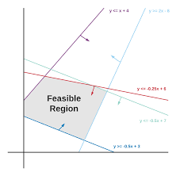In case of manufacturing problem, we find that the maximum profit of company is Rs. 11760.

**REFERENCES**

* <https://www.wikipedia.org/>
* <https://www.britannica.com/>
* <https://www.researchgate.net/>
* <https://www.ijser.org/>
* <https://www.pmcalculators.com/>
* <https://www.mathworks.com/>
* <https://www.youtube.com/>
* <http://www.jcreview.com/>
* <https://core.ac.uk/>
* <https://www.sciencedirect.com/>
* <https://www.techopedia.com/>
* <https://www.analyticsvidhya.com/>